Alberta Council of Women’s Shelters Progress Report on Government Recommendations Relating to Shelters
Final Report

November 19, 2009



TABLE OF CONTENTS

ACWS PROGRESS REPORT SURVEY 1
Summary Of Findings 2
1.0 Project Background 6
2.0 Methodology 7
2.1 Project Initiation and Questionnaire Review 7
2.2 Survey Population and Data Collection 7
2.3 Data Analysis and Project Documentation 8
3.0 Section 1: Premier’s Roundtable On Family Violence And Bullying 9
3.1 Establishing a Single, Cross-Sector Entity for Province-Wide Leadership 10
3.2 Providing Additional Support to Families Escaping Family Violence 13
3.3 Expanding Access to Safe Accommodations 18
3.4 Expanding Support Available to Victims 22
4.0 Section 2: Women’s Emergency Shelter Review Program 25
4.1 Affordable, Safe, Suitable Housing 26
4.2 Transportation 34
4.3 Shelter Operations 38
4.4 Transitional Supports 51
4.5 Complex Needs 55
4.6 Children/Safe Visitation 57
4.7 Prevention/Education/Intervention 61
4.8 Priorities for New or Enhanced Services 63

ACWS SHELTER DIRECTORS IN-DEPTH INTERVIEWS 64
5.0 Study Background 65
6.0 Methodology 66
6.1 Project Initiations And Questionnaire Design 66
6.2 Survey Populations And Data Collection 66
7.0 Summary Of Findings 67
7.1 General Shelter Information 67
7.2 Premier’s Roundtable on Family Violence and Bullying Report 69
7.3 Women’s Emergency Shelter Program Review 72
7.4 Support from the PFVBD 74
7.5 Additional Comments 74

Appendix A –ACWS Progress Report Survey Instrument
Appendix B –In-Depth Interview Survey Instrument

ACWS Progress Report Survey

Summary of Findings

In April 2009, the Alberta Council of Women’s Shelters (ACWS) contracted Banister Research & Consulting Inc. (Banister Research) to conduct a web-based survey with shelter directors, staff, board members, and ACWS stakeholders. The purpose of the study was to monitor the progress of implementation made on recommendations in both the Premier’s Roundtable on Family Violence and Bullying Report (2004) and the Women’s Emergency Shelter Program Review: Final Report (2006).

Research objectives included the following:

- To assess the progress of recommendations made in the 2004 report Premier’s Roundtable on Family Violence and Bullying, on:
- Establishing a single, cross-sector entity for province-wide leadership;
- Providing additional support to families escaping family violence;
- Expanding access to safe accommodations; and
- Expanding the support that is currently available to victims of family violence and abuse.

- To assess the progress of recommendations made in the 2006 report Women’s Emergency Shelter Program Review: Final Report, including the following issues:
- Affordable, safe, suitable housing;
- Transportation for shelter clients;
- Shelter operations;
- Transitional supports;
- Complex needs;
- Children’s needs and safe visitation;
- Prevention, education and intervention; and
- Priorities for new or enhanced services.

From April 28th to May 22nd, 2009, Banister Research conducted a web-based survey with 65 shelter directors, staff, board members and stakeholders of the ACWS. The survey consisted of two sections:
- Section 1 was designed to assess the issues and progress that had occurred in reference to the Premier’s Roundtable on Family Violence and Bullying Report (2004); and
- Section 2 of the survey was designed to assess the progress that had occurred in reference to the Women’s Emergency Shelter Program Review: Final Report (2006).

While all respondents were encouraged to participate in section 1 of the survey, only shelter directors, shelter staff members or members of the board were given the chance to complete section 2 of the survey.

It is important to note that throughout the survey that a rating scale ranging from one to five (where “1” refers to the lowest rating and “5” refers to the highest rating out of a possible five) was employed consistently to assess respondents’ opinions and perceptions (i.e. progress, adequacy, accuracy, satisfaction and effectiveness) in order to establish benchmarks.

Ratings of “1” and “2” represent low ratings of the items being measured (e.g. low satisfaction, low effectiveness) on the one to five scale. A rating of “3” is considered “moderate” while ratings of “4” or “5” are considered high ratings (e.g. high satisfaction, high effectiveness) of the items being measured.

Overall Trends
In general, respondents participating in the ACWS Progress Report Survey indicated that a moderate level of progress had occurred in reference to the both the Premier’s Roundtable on Family Violence and Bullying Report (2004) and the Women’s Emergency Shelter Program Review: Final Report (2006). When asked to assess their level of satisfaction in regards to the progress attained in the areas measured, respondents reported only moderate levels of satisfaction. It is important to note, however, that many respondents chose not to respond to many of the questions posed in the survey, very likely due to a lack of awareness or direct experience.

Specific topic areas of the survey that garnered higher ratings or areas of success, as well as areas that garnered lower ratings or areas of improvement have been detailed on page 4, below and page 5 that follows.

Areas of Success
The following were identified as being areas of success, as they garnered comparatively higher ratings with regards to progress, satisfaction and support by valid respondents. These specific areas included:
- Seventy-seven percent (77%) of respondents stated additional supports were provided to families escaping violence since the Roundtable report (page 13);
- Eight (8) out of the ten (10) respondents that applied to the Victims of Crime fund were successful in receiving funding from this source (page 24); and
- Ninety-three percent (93%) of respondents stated that they have the discretion and flexibility to grant extensions on the length of stay for women in their shelter(s) (page 41).

Areas of Improvement
The following were identified as being potential areas of improvement, as they garnered comparatively lower ratings with regards to progress, satisfaction and support by valid respondents. These specific areas included:
- Half of respondents (51%) reported a low rating of progress made with regards to the recommendation to establish a single, cross-sector entity for province-wide leadership (page 10);
- More than half of respondents (54%) reported a low rating of progress made with regards to the new policy for funding allocations that takes into account best practices (page 18);
- More than half of respondents (68%) reported a low rating of progress made with regards to their local community expanding access to safe second stage housing accommodations (page 20);
- No respondents had been a part of an evaluation of second stage housing by the Province (page 26);
- Only 5% of respondents indicated they had been involved in the development of next steps regarding an evaluation of second stage housing in their community (page 27);

- Less than ten percent of respondents (8%) stated they had received support to identify affordable and transitional housing options in their community (page 28) while less than five percent (4%) of respondents stated they had received support to develop these options in their community by the PFVBD (page 29);
- Twenty percent (20%) of respondents stated their shelter had received support from PFVBD to work collaboratively in order to support abused women to safely stay in their homes (page 30);
- Nineteen percent (19%) of respondents stated their shelter was collaborating with PFVBD to explore collaborative options to better meet the needs of women in need and in crisis situations who are not abused but are outside of Children and Youth Services women’s shelter program mandate (page 39);
- Eight percent (8%) of respondents felt PFVBD had raised the potential of additional support in order to address the challenges of communal living (page 42) while seven percent (7%) stated they had received additional support in order to address these challenges (page 44);
- More than half (53%) of respondents provided a low rating with regards to the accuracy of PFVBD’s assessment of operating pressures in their shelter (page 45);
- Thirteen percent (13%) of respondents were satisfied regarding the support received from the government for cross sector training (page 53).
- Respondents provided low mean ratings with regards to the progress made in priority areas for new and enhanced client services, specifically in the following areas (page 61):
  - Improved access to safe, affordable housing (mean of 2.04 out of 5);
  - Increased capacity (training, staffing) to provide one-on-one support to women and children with multiple and complex needs, including mental health and addictions issues (mean of 1.95 out of 5); and
  - Increased support for transportation (mean of 1.86 out of 5).

PROJECT BACKGROUND
In April 2009, the Alberta Council of Women’s Shelters (ACWS) contracted Banister Research & Consulting Inc. (Banister Research) to conduct a web-based survey with shelter directors, staff, board members, and ACWS stakeholders. The purpose of the study was to monitor the progress of implementations made on recommendations in both the Premier’s Roundtable on Family Violence and Bullying Report (2004) and the Women’s Emergency Shelter Program Review: Final Report (2006).

Research objectives included the following:

- To assess the progress of recommendations made in the 2004 report Premier’s Roundtable on Family Violence and Bullying, on:
- Establishing a single, cross-sector entity for province-wide leadership;
- Providing additional support to families escaping family violence;
- Expanding access to safe accommodations; and
- Expanding the support that is currently available to victims of family violence and abuse.

- To assess the progress of recommendations made in the 2006 report Women’s Emergency Shelter Program Review: Final Report, including the following issues:
- Affordable, safe, suitable housing;
- Transportation for shelter clients;
- Shelter operations;
- Transitional supports;
- Complex needs;
- Children’s needs and safe visitation;
- Prevention, education and intervention; and
- Priorities for new or enhanced services.

  - METHODOLOGY
All components of the project were designed and executed in close consultation with ACWS (the Client). A detailed description of each task of the project is outlined in the remainder of this section.

Project Initiation and Questionnaire Review
At the outset of the project, all background information relevant to the study was identified and subsequently reviewed by Banister Research. The consulting team familiarized itself with the objectives of the Client ensuring a full understanding of the issues and concerns to be addressed in the project. The result of this task was an agreement on the research methodology, a detailed work plan and project initiation.

The survey instrument utilized in the study was designed by the ACWS and Banister Research. In consultation with the Client, the questions were reviewed and the questionnaire was finalized. A copy of the final questionnaire is provided in Appendix A.

Survey Population and Data Collection

The on-line survey was available from April 28th to May 22nd, 2009. The survey was hosted on the Banister web server to ensure confidentiality of responses. A total population of 171 individuals identified by the ACWS were e-mailed an invitation to participate in the survey. In order to maximize the response rate, up to three e-mail reminders were sent to non-respondents over the course of data collection.

Banister Research received a total of 65 completed responses from the survey population. It is important to note that there were a number of factors that had the potential to impact the response rate of the survey including:
- The length of time that has passed since the implementation of recommendations from these reports;
- The incidence rate of Shelter Directors not serving in that role when the reports were first published; and/or
- A general lack of awareness of, and familiarity with, the reports being researched.

The results depicted in this report reflect an accuracy level or margin of error no greater than +9.6% at the 95% confidence level or 19 times out of 20. It is important to note when considering the survey findings, the reader should note that the sample error tolerances associated as the size of sample sub-groups vary.

Data Analysis and Project Documentation

Tabulations of the detailed data tables have been provided electronically under separate cover. It is important to note that any discrepancies between charts, graphs or tables are due to rounding of the numbers.

Section 1 that follows provides a detailed description of the 2009 ACWS Progress Report Survey.

  - SECTION 1: Premier’s Roundtable on Family Violence and Bullying
All respondents (n=65) were instructed to complete Section 1 of the survey referring specifically to the Premier’s Roundtable on Family Violence and Bullying Report (2004). This section of the survey contained questions designed to assess the progress made and consequent satisfaction regarding the implementation of recommendations made in this above noted report.

It is important to note that throughout the survey that a rating scale ranging from one to five (where “1” refers to the lowest rating and “5” refers to the highest rating out of a possible five) was employed consistently to assess respondents’ opinions and perceptions (i.e. progress, adequacy, accuracy, satisfaction and effectiveness) in order to establish benchmarks.

Ratings of “1” and “2” represent low ratings of the items being measured (e.g. low satisfaction, low effectiveness) on the one to five scale. A rating of “3” is considered “moderate” while ratings of “4” or “5” are considered high ratings (e.g. high satisfaction, high effectiveness) of the items being measured.

There are two percentages detailed in many of the figures in Section 1:
- The percentages reported for “All Respondents” is based consistently on the total number of respondents that completed the survey (n=65) and includes those that provided a “Don’t know “ response or those that did not provide a response.
- The percentage reported for “Valid Respondents” have been calculated based on only those that provided a response to the question and excludes those that provided a “don’t know” response or chose not to respond entirely. The number of “Valid Respondents”, therefore, varies from question to question.

Caution should be used when interpreting these results due to the low number of “valid” respondents.

Establishing a Single, Cross-Sector Entity for Province-Wide Leadership
To begin the survey, respondents were asked to rate the progress that has been achieved on the recommendation to establish a single, cross-sector entity for province-wide leadership (for an exert detailing the specific details of this recommendation, please see the footnote below).

Eleven percent (11%) of all respondents felt that excellent progress had been made with regards to establishing a single, cross-sector entity for province-wide leadership (4 or 5 out of 5). Fifteen percent (15%) of respondents indicated that a moderate amount of progress had been made (3 out of 5), while 28% of respondents stated that little or no progress has been made (1 or 2 out of 5). It is important to note that 32% of all respondents provided a “don’t know”, while 14% of respondents did not respond at all.

Amongst those that provided a response (n=35), 20% indicated that excellent progress (4 or 5 out of 5) has been made with regards to this recommendation. See Figure 1, below.
Figure 1
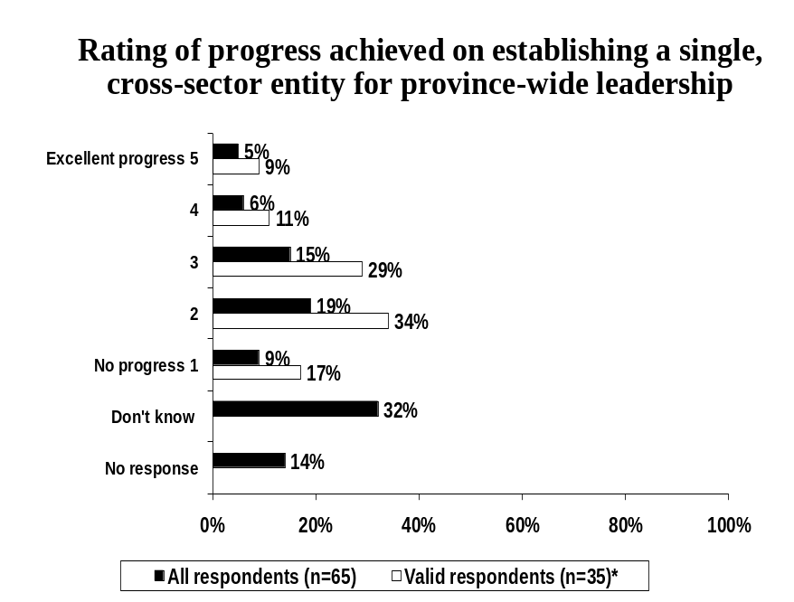

Respondents were asked to detail the reasons behind their rating of progress regarding the recommendation to establish a single cross-sector entity for province-wide leadership.

Respondents that provided a low rating regarding the progress achieved (1 or 2 out of 5), frequently indicated that they were not familiar with the committee or entity that had been established (6 respondents), followed by a general lack of communication or the poor timing of communication regarding this entity (4 respondents) and the lack of visible change (2 respondents). See Table 1, below, for a list of all reasons provided.

Table 1
Why do you feel this way?*
Base: Respondents that provided a low progress rating (1 or 2 out of 5) for the recommendation of establishing a single cross-sector entity for province-wide leadership | Number of Respondents (n=18)
Not familiar with committee/there is no committee | 6
Lack of communication/untimely communication | 4
Have not seen any change | 2
Would recommend this be community based (not government) | 1
There is nothing in place that organizes community and government | 1
Messages are negative/not helpful | 1
Would like to know what is being done in Aboriginal shelters | 1
Would like it to be quasi-independent (e.g. Alberta Alcohol and Drug Abuse) | 1
Do not feel that there is a Provincial plan in place to address the issue | 1
There is no support/resources available to outside agencies | 1
Don’t know/No response | 1
*Multiple mentions

Respondents that provided a moderate to high rating (3, 4 or 5 out of 5) of the progress made regarding this recommendation most frequently indicated the process is still in the development or early stages (2 respondents), that progress has been slow with a lack of significant outcomes (2 respondents) and there is inequality in shelter funding (2 respondents). See Table 2, below for a list of all reasons mentioned.

Table 2
Why do you feel this way?*
Base: Respondents that provided a moderate or high progress rating (3, 4 or 5 out of 5) for the recommendation of establishing a single cross-sector entity for province-wide leadership | Number of Respondents (n=17)
Appears to be developing/early stages/process has begun | 2
Progress is slow/few or no significant outcomes | 2
Inequality in shelter funding (some shelters have more than others) | 2
Would like to know what is being done in Aboriginal shelters | 1
Lack of communication/untimely communication | 1
Have not seen any changes | 1
Shelters not included in the process | 1
Don’t believe this will improve services | 1
Need more educational opportunities | 1
There is nothing in place that organizes community and government | 1
There is a common voice that speaks to the issue | 1
Don’t know/No response | 6
*Multiple mentions

Providing Additional Support to Families Escaping Family Violence
Next, respondents were asked if additional supports had been provided to families escaping family violence since the Roundtable report, in regards to the recommendation that transition funding is an important way of supporting families escaping violent situations (for an exert detailing the specific details of this recommendation, please see the footnote below).

More than half of all respondents (52%) stated that additional supports were provided since the Roundtable Report, while 15% of respondents stated that no additional supports have been provided.

Seventy-seven percent (77%) of valid respondents (n=44), or those that provided a response, stated that additional supports were provided, while 23% disagreed. See Figure 2, below.

Figure 2
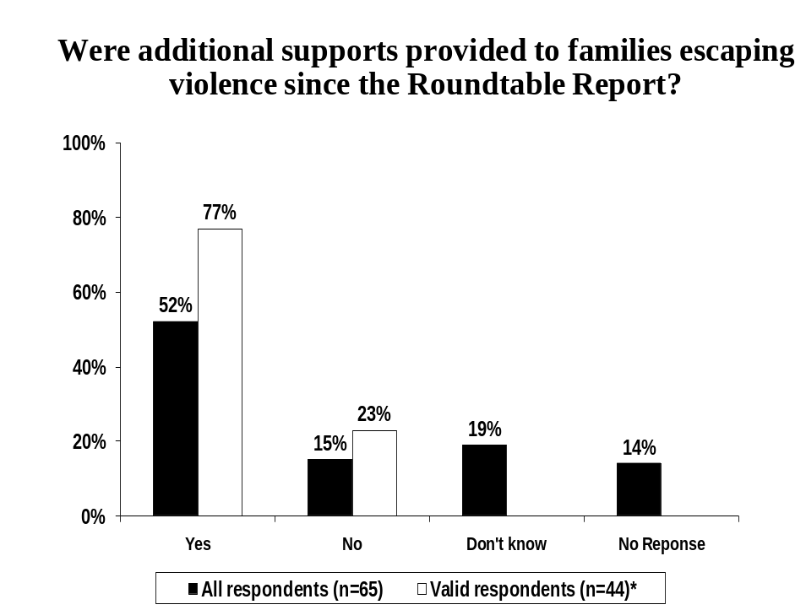
* Excludes “Don’t know” and “No response”

Those respondents that indicated additional supports were provided to families (n=34) were asked to rate the effectiveness of these supports. More than one-third (35%) of respondents considered these supports to be highly effective (4 or 5 out of 5), while 44% reported a moderate rating of effectiveness (3 out of 5). Only 12% of respondents provided a low rating of the effectiveness (1 or 2 out of 5) of the additional supports provided to families.

Thirty-eight percent (38%) of valid respondents or those that provided a rating (n=31), indicated these supports were highly effective. See Figure 3, below.

Figure 3
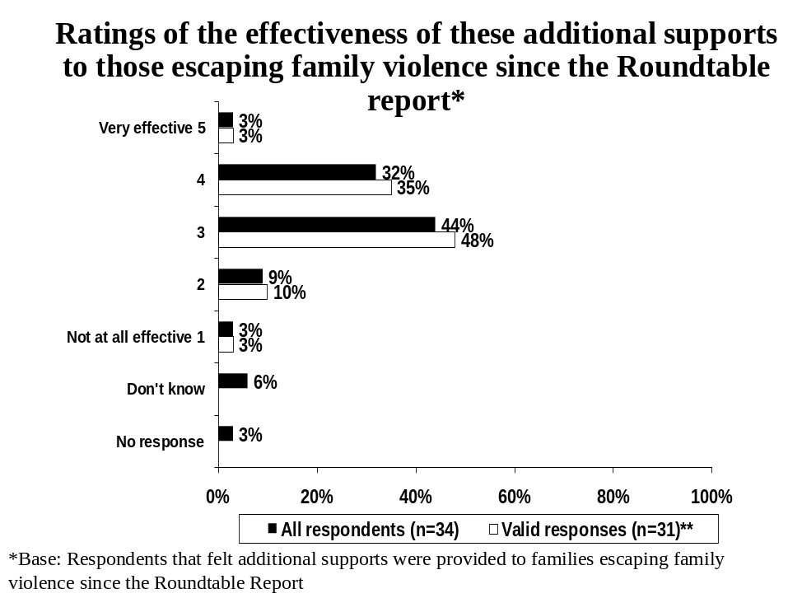
** Excludes “Don’t know” and “No response”

Respondents were asked to provide reasons for selecting their effectiveness rating of these additional supports. Respondents that provided a low effectiveness rating (n=4) frequently indicated that while the additional funding is valuable and effective (2 respondents) there is a lack of support in general (2 respondents). See Table 3, below for additional reasons mentioned by respondents.

Table 3
Why do you feel this way?*
Base: Respondents that provided a low effectiveness rating (1 or 2 out of 5) of additional supports | Number of Respondents (n=4)
Funding is valuable/effective | 2
The support is not enough | 2
Hard to obtain the funds | 1
Inconsistent criteria between offices/workers | 1
Sustainable funding is needed instead | 1
Funding is too sporadic | 1
*Multiple mentions

Respondents that provided a moderate to high effectiveness rating (n=27) frequently highlighted that the start-up funding is helpful or useful (7 respondents), the funding being valuable or effective (6 respondents) and the inconsistency in the criteria between offices or workers (3 respondents). See Table 4, below for additional reasons mentioned by respondents.

Table 4
Why do you feel this way?*
Base: Respondents that provided a moderate or high effectiveness rating (3, 4 or 5 out of 5) of additional supports | Number of Respondents (n=27)
The start-up fund is helpful/useful | 7
Funding is valuable/effective | 6
Inconsistent criteria between offices/workers | 3
The support is not enough | 2
Outreach program is good | 2
The fleeing violence benefit is a great help | 2
Subsidized/second stage housing has not been addressed | 2
Other (single mentions only) | 13
Don’t know/No response | 6
*Multiple mentions

Respondents were asked if the process had been streamlined and/or improved for families escaping violence. One-quarter (25%) of respondents stated that the process had been streamlined and/or improved, while 34% indicated that it had not.

Forty-two percent (42%) of valid respondents or those that provided a response (n=38) stated that the process has been streamlined and/or improved, while more than half (58%) felt it had not. See Figure 4, below.

Figure 4
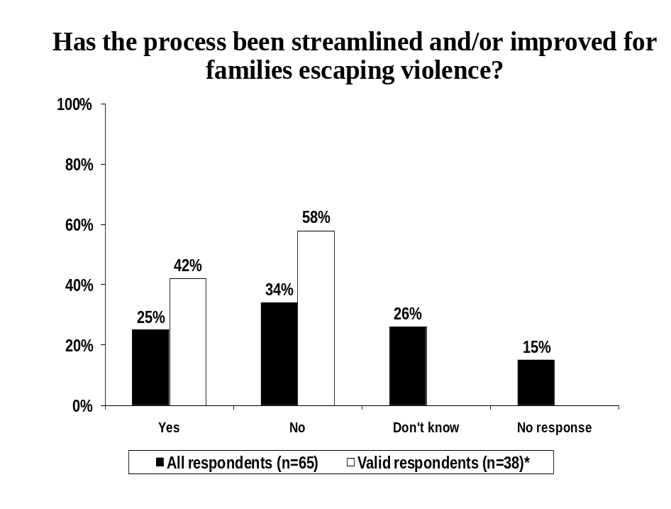
* Excludes “Don’t know” and “No response”

Respondents that felt the process had been streamlined and/or improved (n=16) were asked to indicate the effectiveness of the streamlined process. Eight respondents (n=8) provided a high effectiveness rating, while seven (7) respondents reported a moderate rating of effectiveness. One respondent (n=1) was unable to provide a rating. See Figure 5, below.

Figure 5
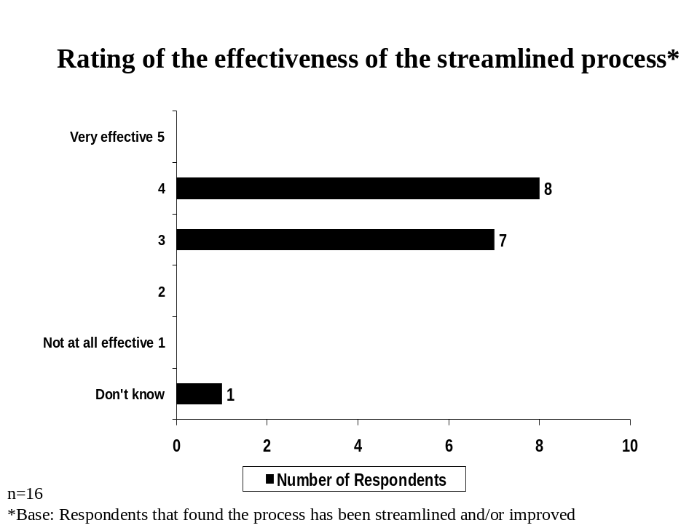

Reasons given for providing a moderate or high effectiveness rating of the streamlined process (n=15), included that it was easier for families to get financial support (2 respondents), followed by the need for more change (2 respondents). See Table 5, below.

Table 5
Why do you feel this way?*
Base: Respondents that provided a moderate or high effectiveness rating (3, 4 or 5 out of 5) of the streamlined process | Number of Respondents (n=15)
Easier for families to get financial support | 2
Much more still needs to be done/need more change | 2
Other (single mentions only) | 11
Don’t know/No response | 7
*Multiple mentions

Expanding Access to Safe Accommodations
Next, respondents were asked to rate the progress made on the new policy of funding allocations that takes into account best practices (for an exert of the specific details of this recommendation, please see the footnote below).

Only five percent (5%) of respondents stated that excellent (4 or 5 out of 5) progress had been made with regards to this recommendation, 20% of respondents indicated that moderate progress had been made and 30% of respondents stated that little or no progress had been made.

Nine-percent (9%) of valid respondents or those that provided a rating (n=35), stated that excellent progress has been made. See Figure 6, below.

Figure 6
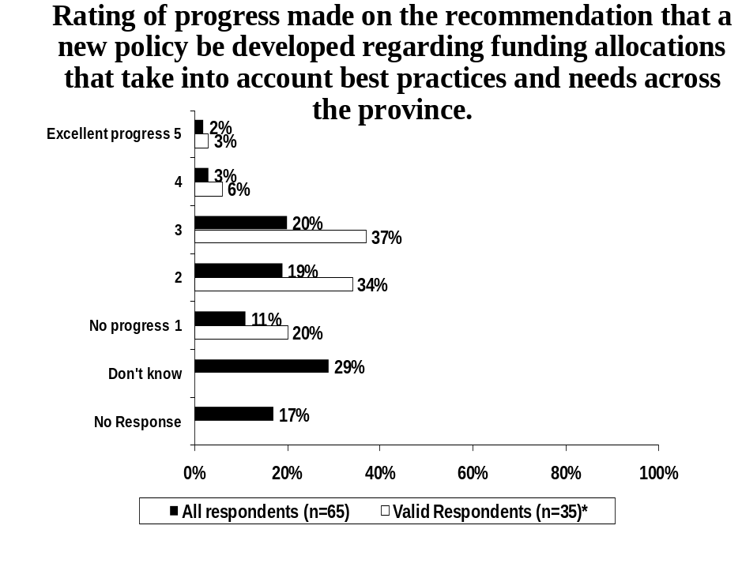
* Excludes “Don’t know” and “No response”

Respondents were asked to indicate why they provided their particular rating of progress made on a new policy regarding funding allocations that takes into account best practices. Respondents that provided a low progress rating (n=19), most frequently indicated a need for transitional or second stage housing (6 respondents), followed by a lack of progress in general (5 respondents), and a need for more beds or increased funding for beds (2 respondents). See Table 6, below for additional reasons provided by respondents.

Table 6
Why do you feel this way?*
Base: Respondents that provided a low progress rating (1 or 2 out of 5) made on a new policy regarding funding allocations that takes into account best practices | Number of Respondents (n=19)
Need transitional housing/second stage housing | 6
Have seen no progress/unsure of progress | 5
More beds/funding for beds is needed | 2
Other (single mentions) | 10
Don’t know/No response | 2
*Multiple mentions

Respondents that provided a moderate to high progress rating regarding this recommendation (n=16), frequently mentioned the need for transitional housing (4 respondents), a lack of progress in general (2 respondents), and that a large effort had been put into this recommendation (2 respondents). See Table 7, below for additional reasons provided by respondents.

Table 7
Why do you feel this way?*
Base: Respondents that provided a moderate or high progress rating (3, 4 or 5 out of 5) made on a new policy regarding funding allocations that takes into account best practices | Number of Respondents (n=16)
Need transitional housing/second stage housing | 4
Have seen no progress/unsure of progress | 2
Lots of effort have been put into this | 2
Other (single mentions) | 9
Don’t know/No response | 5
*Multiple mentions

Respondents were asked to rate the progress that had been made in regards to the recommendation that their local community expand access to safe second stage accommodations (for an exert of the specific details of this recommendation, please see the footnote below).

Twelve percent (12%) of respondents felt that excellent progress has been made regard to this recommendation, 12% reported a moderate level of progress had been achieved, while more than half (54%) of respondents indicated little or no progress had been made.

Sixteen percent (16%) of valid respondents or those that provided a rating (n=51) stated excellent progress has been made. See Figure 7, below.

Figure 7
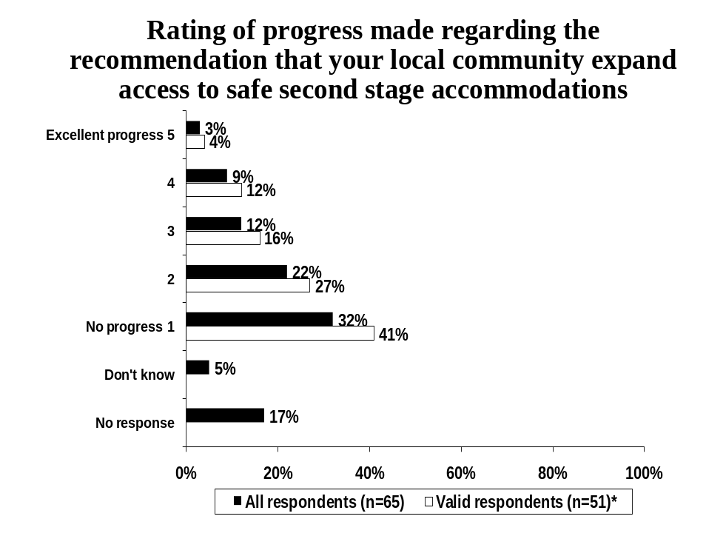
* Excludes “Don’t know” and “No response”

Respondents were asked to indicate why they provided their particular rating for progress made in their local community to expand access to second stage housing (n=35). The general lack of second stage housing was highlighted by 26% of respondents as being the reason for providing a low progress rating. Other mentions included the lack of support by local council (9%) and a lack of funding available at facilities (9%). See Table 8, below for a list of all reasons provided

Table 8
Why do you feel this way?*
Base: Respondents that provided a low rating (1 or 2 out of 5) for progress made in their local community to expand access to second stage housing | Percent of Respondents (n=35)
There is no second stage housing/no progress | 26
Local council is not supportive/not getting more affordable housing | 9
We are not receiving funding at our facility/difficult to get funding | 9
Need more emergency beds | 6
Still lacking affordable/supportive housing | 6
The need for second stage housing is critical | 6
Other (single mentions) | 35
Don’t’ know/No response | 14
*Multiple mentions

Respondents that provided a moderate to high progress rating (n=16), most frequently indicated that progress being made to receive or expand second stage housing (4 respondents) was the reason for their rating. See Table 9, below for a list of all reasons provided.

Table 9
Why do you feel this way?*
Base: Respondents that provided a moderate or high rating (3, 4 or 5 out of 5) for progress made in their local community to expand access to second stage housing | Number of Respondents (n=16)
Progress is being made to get/expand second stage housing | 4
We are not receiving funding at our facility/difficult to get funding | 1
Council has only drafted as letter of support | 1
Getting support from council is not difficult | 1
Need more emergency beds | 1
Money is only being focused in Edmonton and Calgary | 1
Dissatisfaction with lack of a provincial program to fund housing | 1
Need more awareness in community of what second stage housing is | 1
Homeless service providers don’t address family violence/poverty issues | 1
Needs to be a higher profile | 1
Don’t know/No response | 7
*Multiple mentions

Expanding Support Available to Victims
As illustrated in Figure 8, below, 15% of all respondents indicated that they had applied to the Victims of Crime Fund, the fund designed to assist organizations that help victims of crime during their involvement with the criminal justice system, as per the recommendation detailed in the footnote below, while 49% stated they had not.

This percentage increases to 24% when considering only valid respondents, or those that provided a response (n=42).

Figure 8
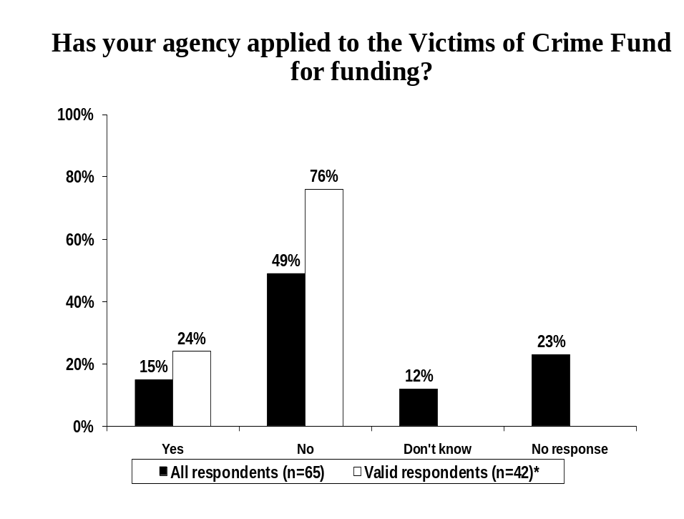
* Excludes “Don’t know” and “No response”

Respondents that had applied to the Victims of Crime Funding (n=10) were asked if they were successful in obtaining funding. Eight (n=8) respondents indicated that they were successful, while two (n=2) reported that they were not successful in obtaining funding from the Victims of Crime Fund. See Figure 9, below.

Figure 9
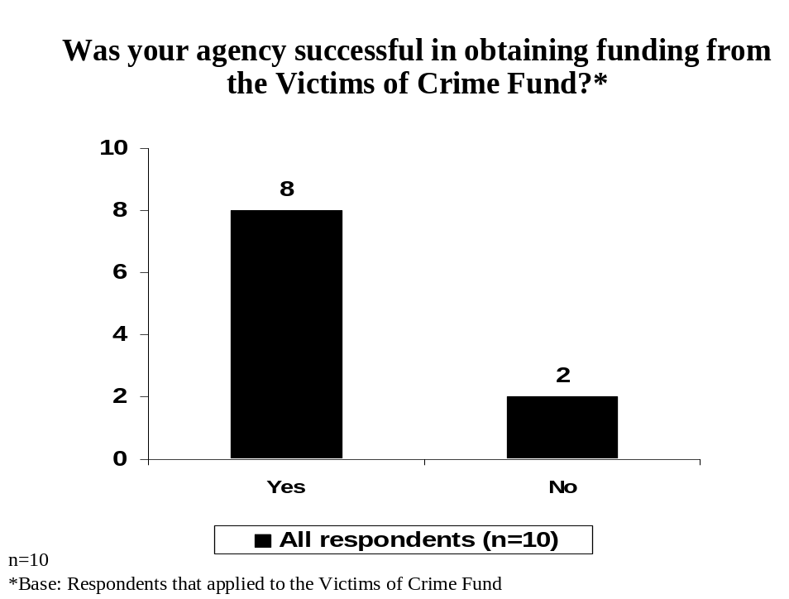

Next, respondents that indicated they were successful in receiving the funds were asked how effective the funding was for individual women using their agency’s services (n=8). As depicted in Figure 10, below, two (2) respondents provided a moderate rating of effectiveness, while one respondent considered the funding to be effective (rating of 4 out of 5) and another respondent felt the funding was not effective (rating of 2 out of 5). Four (4) respondents were unable to provide a response.

Figure 10
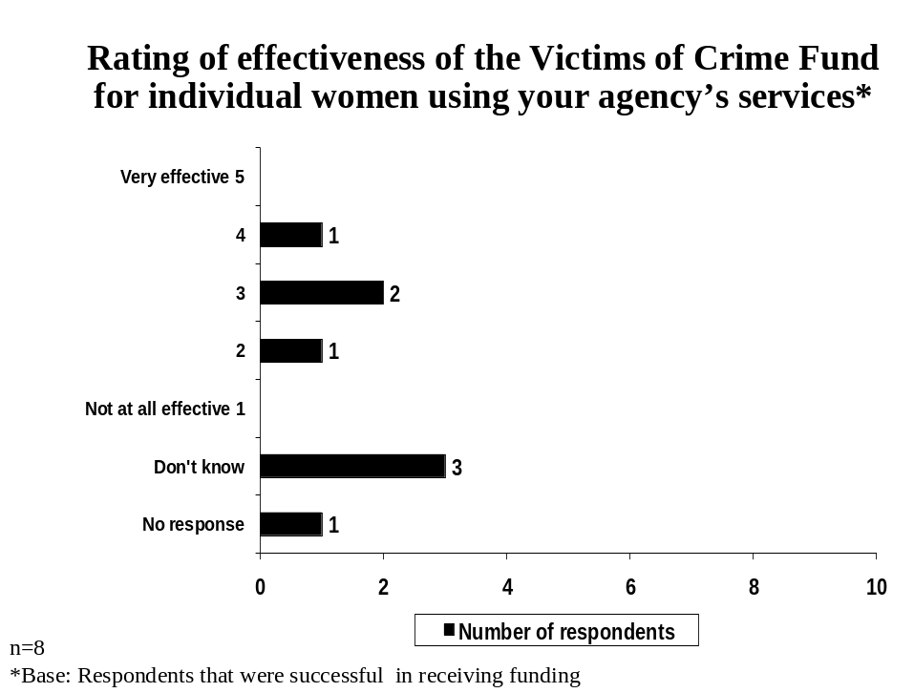

  - SECTION 2: WOMEN’S EMERGENCY SHELTER REVIEW PROGRAM

Only respondents that identified themselves as shelter directors, staff members or board members (n=39) were instructed to complete Section 2 of the survey referring specifically to the Women’s Emergency Shelter Program Review: Final Report (2006). This section of the survey contained questions designed to assess the progress made and consequent satisfaction regarding the implementation of recommendations made in this above noted report.

It is important to note that throughout the survey that a rating scale ranging from one to five (where “1” refers to the lowest rating and “5” refers to the highest rating out of a possible five) was employed consistently to assess respondents’ opinions and perceptions (i.e. progress, adequacy, accuracy, satisfaction and effectiveness) in order to establish benchmarks.

Ratings of “1” and “2” represent low ratings of the items being measured (e.g. low satisfaction, low effectiveness) on the one to five scale. A rating of “3” is considered “moderate” while ratings of “4” or “5” are considered high ratings (e.g. high satisfaction, high effectiveness) of the items being measured.

Again, there are two percentages detailed in many of the figures in Section 2:
- The percentages reported for “All Respondents” is based consistently on the total number of respondents that completed the survey (n=39) and includes those that provided a “Don’t know “ response or those that did not provide a response.
- The percentage reported for “Valid Respondents” have been calculated on only those that provided a response to the question and excludes those that provided a “don’t know” response or chose not to respond entirely. The number of “Valid Respondents”, therefore, varies from question to question.

Caution should be used when interpreting these results due to the low number of “valid” respondents.

Affordable, Safe, Suitable Housing
As illustrated in Figure 11, below, none of respondents indicated that they had been part of an evaluation of second stage housing by the Province, while 72% reported that they had not been a part of an evaluation. Twenty-eight percent (28%) were unable to provide a response.

When considering only valid respondents or those that provided a response (n=28), all respondents (100%) indicated that they had not been part of an evaluation.

Figure 11
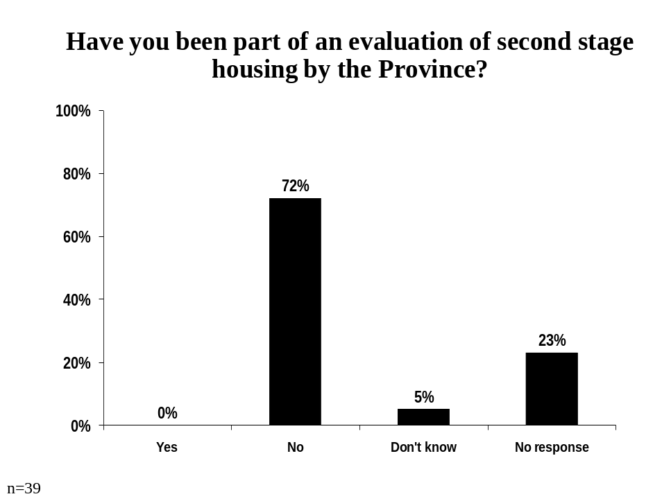

Respondents were asked to indicate if they had been involved in the development of recommendations for the next steps regarding an evaluation of second stage housing by the province. Only 5% of respondents indicated that they had been involved in the development of the next steps regarding an evaluation of second stage housing by the province.

When considering only valid respondents or those that provided a response, 7% of respondents indicated they had been involved in the next steps of an evaluation. See Figure 12, below.

Figure 12
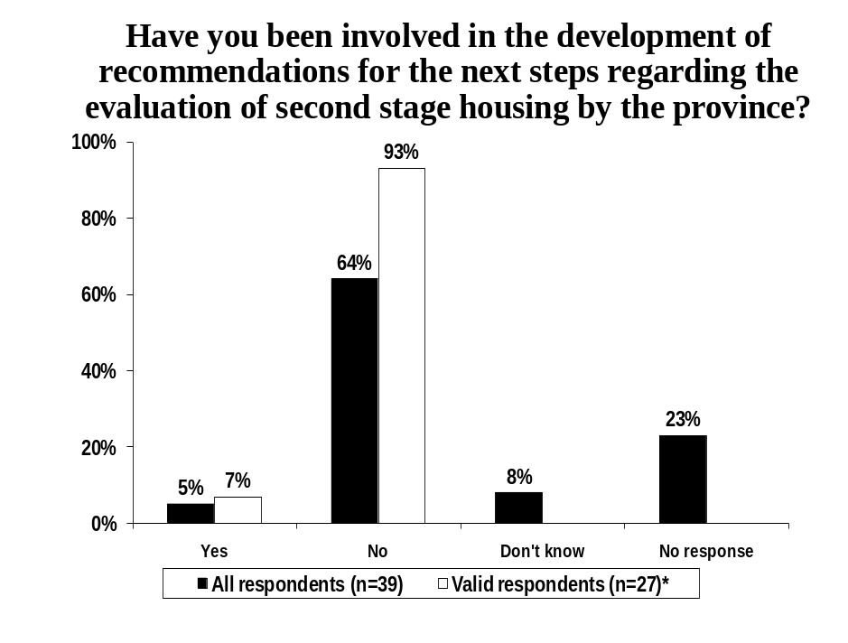
* Excludes “Don’t know” and “No response”

Respondents that were involved in the development of recommendations for the next steps of an evaluation of second stage housing by the province (n=2) were asked to explain how they have been involved See Table 10, below, for all reasons provided by these respondents.

Table 10
How Have You Been Involved?*
Base: Respondents that were involved in the development of recommendations for the next steps of an evaluation of second stage housing by the province | Number of Respondents (n=2)
Involved through ACWS | 1
Participated in the Roundtable | 1
Meetings with Alberta Children and Youth Services | 1
Letters to the Province with recommendations | 1
*Multiple mentions

Next, respondents were asked if they had received support from the Prevention of Family Violence and Bullying Division (PFVBD) to identify affordable and transitional housing options in their community (please refer to the footnote below for an exert regarding this recommendation). Only 5% of respondents indicated that they have been supported by PFVBD, while 56% reported they have not. Thirty-nine percent (39%) of respondents did not provide a response or were unsure.

When considering only valid respondents or those that provided a response (n=24), only 8% had received this support, while the vast majority of respondents (92%) indicated that they were not being supported by PFVBD to identify affordable and transitional housing options in their community. See Figure 13, below.

Figure 13
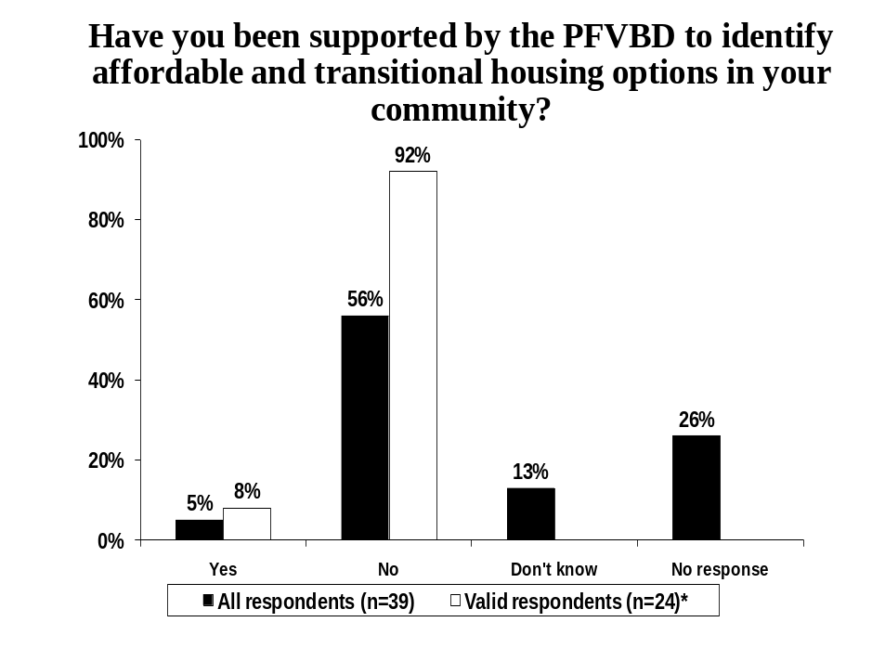
* Excludes “Don’t know” and “No response”

Respondents that indicated that they were supported by PFVBD (n=2) mentioned they received support in the form of encouragement to partner at the community level (n=1) and through crisis intervention workers working with spousal intervention teams (n=1).

Only three percent (3%) of respondents indicated that they had received support from PFVBD to develop affordable and transitional housing options within their community, while 69% reported they had not. Twenty-eight percent (28%) of respondents did not provide a response or were unsure.

When considering only valid respondents or those that provided a response (n=28), only 4% had received this support while the vast majority of respondents (96%) indicated that they were not being supported by PFVBD to develop affordable and transitional housing options. See Figure 14, below.

Figure 14
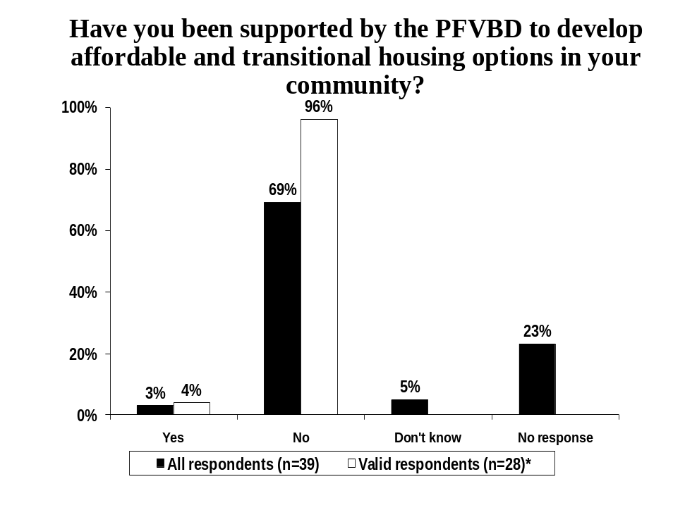
* Excludes “Don’t know” and “No response”

Thirteen percent (13%) of respondents indicated their shelter received support from PFVBD to work collaboratively together in order to support abused women to safely stay in their homes (for more detail regarding this recommendation refer to the footnote below). Thirty-six percent (36%) of respondents were unable to provide a response.

Twenty percent (20%) of valid respondents or those that provided a response (n=25) indicated that their shelter had received support from PFVBD, while eighty percent (80%) had not. See Figure 15, below.

Figure 15
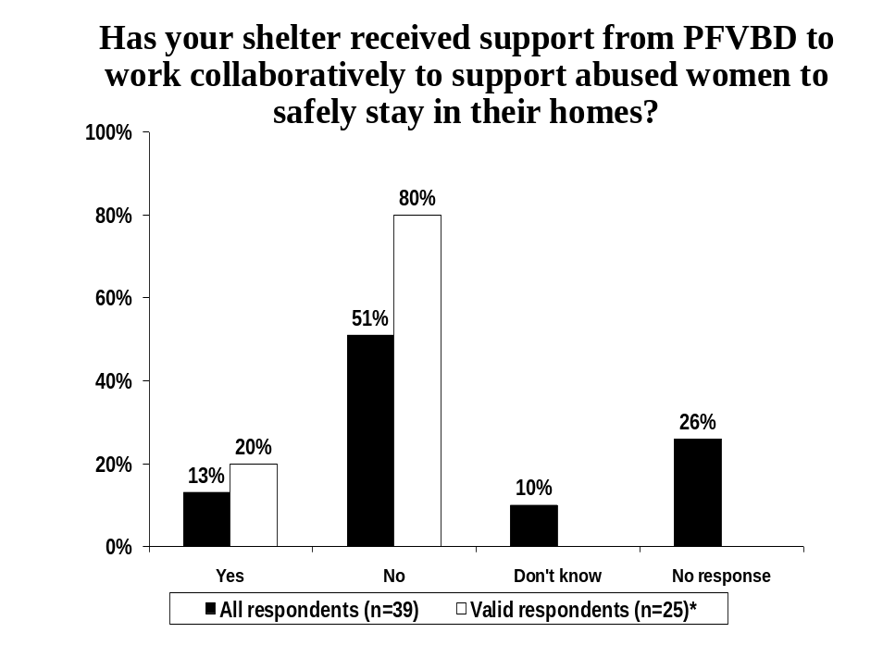
* Excludes “Don’t know” and “No response”

Respondents that indicated they were supported by PFVBD (n=5) mentioned they received funding for outreach programs or workers (3 respondents), training sessions offered by the RCMP or other service agencies (1 respondent), support by telephone (1 respondent), or received support through recommendations (1 respondent).

Respondents that indicated they had received support from PFVBD to support abused women to safely stay in their home (n=5) were asked to rate the adequacy of this support. As depicted in Figure 16, below, two (2) respondents provided a high rating of adequacy, two (2) respondents reported a moderate rating, while one (1) respondent provided a low rating regarding the adequacy of these supports provided by PFVBD.

Figure 16
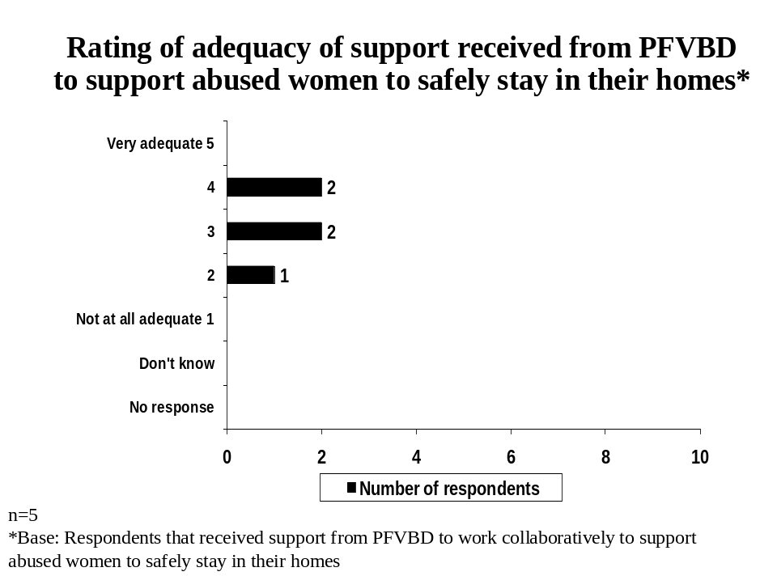

The single respondent that provided a low rating for the adequacy of support received from PFVBD indicated that more outreach workers were needed.

Respondents that provided a moderate or high adequacy rating (n=4) mentioned that training was only part of the larger issue (1 respondent), that more resources were needed (1 respondent) and that information is sometimes sparse (1 respondent). One respondent stated they were new to the position (1 respondent) and unable to provide additional comments.

All respondents were then asked if they had any additional comments regarding the support offered from PFVBD. Ten percent (10%) of respondents reported they have had limited or no contact with PFVBD, while 5% mentioned they were pleased with the funding increases. See Table 11, below for all the responses provided.

Table 11
Additional comments about support offered from PFVBD*
 | Percent of Respondents (n=39)
Have had no contact with PFVBD/limited contact | 10
Pleased with funding increases | 5
No relationship beyond contracts/financial reporting | 3
Not updated on achieving identity changes or transportation | 3
Materials available that help public education and awareness programs | 3
More transitional housing/transitional housing funding needed | 3
They provide more hassle than support | 3
PFVBD should work with on-reserve shelters and band councils | 3
Have not received any support | 3
PFVBD should look at shelters best practices | 3
Participated on a ACWS task group with a PFVBD representative | 3
Don’t see PFVBD as an agency that tries to eliminate family violence | 3
Don’t know/No response | 67
*Multiple mentions

Transportation
Five percent (5%) of respondents indicated that their shelter had been involved with PFVBD to assess transportation options, while 62% had not (refer to the footnote below for more information). Thirty-three percent (33%) of respondents did not provide a response.

Only eight percent (8%) of valid respondents or those that provided a response (n=26) stated that their shelter had been involved with PFVBD to assess transportation options. See Figure 17, below.

Figure 17
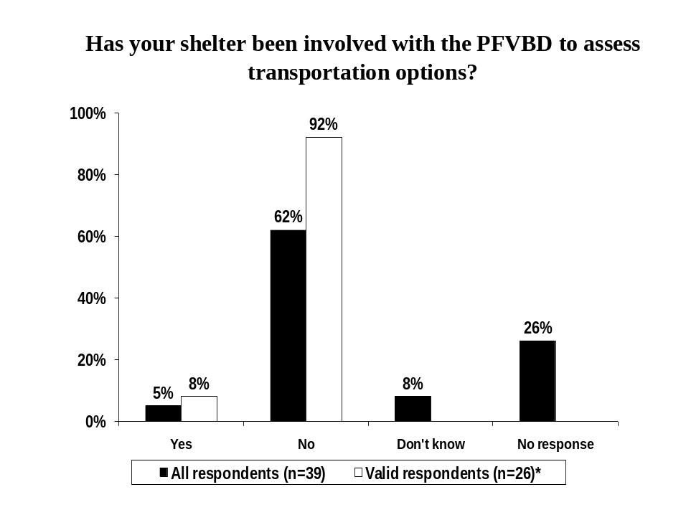
* Excludes “Don’t know” and “No response”

Respondents that indicated their shelter had been involved with PFVBD to assess transportation options (n=2) mentioned that they received a budget to provide transportation for women in rural areas (1 respondent) or that they received a taxi reimbursement due to a lack of public transit (1 respondent).

Respondents that had been involved with PFVBD to assess transportation options were asked to rate the adequacy of support received from PFVBD (n=2). One respondent (n=1) provided a low adequacy rating (1 out of 5), while another respondent indicated a moderate rating (3 out of 5) of the adequacy of these supports.

The respondent that indicated a low adequacy rating reported that the level of funding did not change (1 respondent), while the respondent that provided the moderate rating indicated that taxis only run during the daytime hours in rural areas (1 respondent).

Five percent (5%) of respondents indicated that it would be beneficial to be on the assessment team when asked if they had any additional comments regarding PFVBD assessing transportation options. See Table 12, below.

Table 12
Additional comments regarding PFVBD assessing transportation options*
 | Percent of Respondents (n=39)
Would be good to be on the assessment team | 5
Needs work (unspecified) | 3
Negotiate contracts based on actual costs | 3
Alberta Works is supposed to fund transportation but they are not effective | 3
Emergency Social Services has been good | 3
PVFBD has not been helpful | 3
The needs of second stage shelters are not recognized | 3
Might be useful instead of building shelters in remote communities | 3
Don’t know/No response | 80
*Multiple mentions

As depicted in Figure 18, below, 15% of respondents indicated they received dedicated resources to meet the transportation needs of clients to access the shelter, while 41% reported that they did not. Forty-four percent (44%) of respondents did not provide a response or were unsure.

Twenty-seven percent (27%) of valid respondents or those that provided a response (n=22) stated that their shelter received dedicated resources to meet the transportation needs of clients.

Figure 18
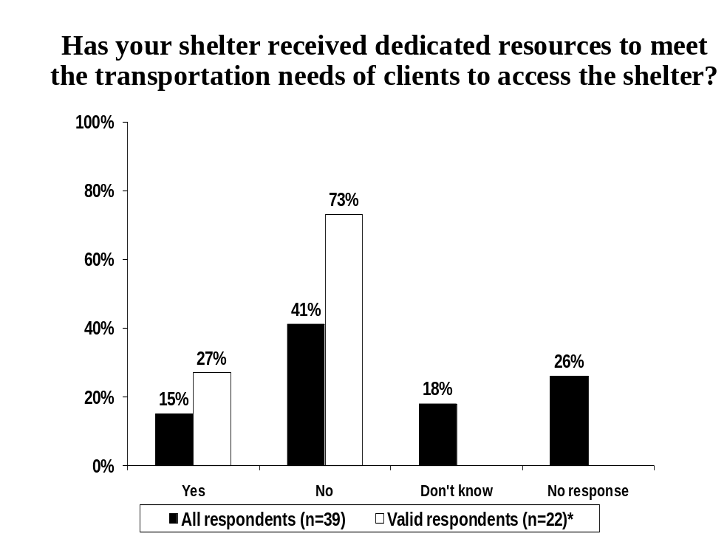
* Excludes “Don’t know” and “No response”

Respondents that indicated their shelter had received dedicated resources to address the transportation needs of their clients (n=6) were asked to describe what resources they had received. Four respondents (n=4) indicated that they received funding allocated towards transportation, while other mentions included receiving a taxi reimbursement (1 respondent) and a budget for transportation costs (1 respondent).

Respondents that indicated they had received support in the form of dedicated resources to address the transportation needs of clients (n=6) were asked to rate the adequacy of these resources. As illustrated in Figure 19, below, 2 respondents rated the adequacy of these resources a being high (4 out of 5), 3 respondents provided a moderate rating (3 out of 5), while 1 respondent rated the adequacy of the resources as being low (2 out of 5).

Figure 19
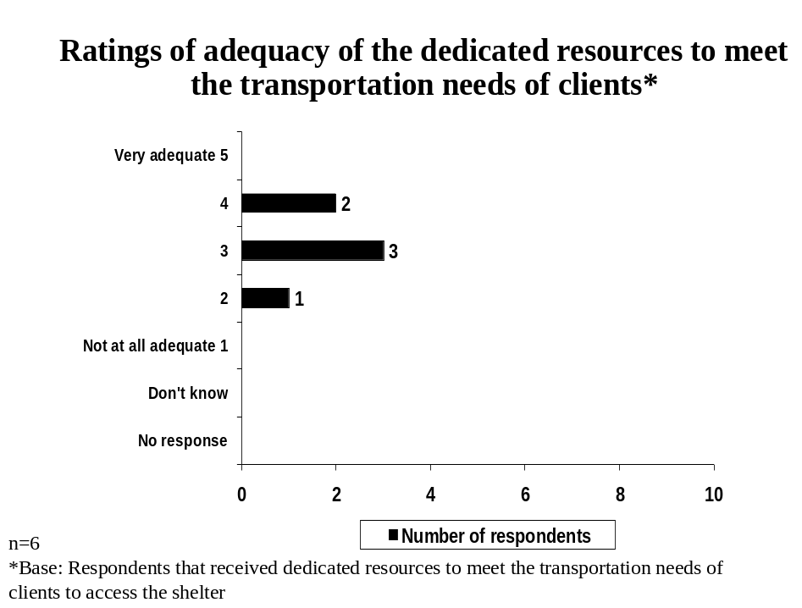

When asked to indicate why they provided their rating, the single respondent that provided a low adequacy rating stated that the shelter had to raise funds in order to meet their transportation needs (1 respondent).

Those that provided either a moderate or high adequacy rating (5 respondents in total) mentioned that transportation in rural areas can be costly or complicated (2 respondents), there is a general lack of these resources (2 respondents) and that the current resources meet the needs of women in larger urban centres (1 respondent).

Shelter Operations
Respondents were asked to rate the progress made in simplifying data collection and reporting (refer to the footnote below for further detail regarding this recommendation).

Fifteen percent (15%) of respondents indicated that excellent progress had been made, while 23% stated moderate progress made in simplifying data collection and reporting. One-fifth (20%) of respondents provided a low rating of progress achieved in simplifying data collection and reporting, while 41% of respondents did not provide a rating.

Twenty-six percent (26%) of valid respondents or those that provided a rating (n=23) indicated a high level of progress had been achieved in this regard. See Figure 20, below.

Figure 20
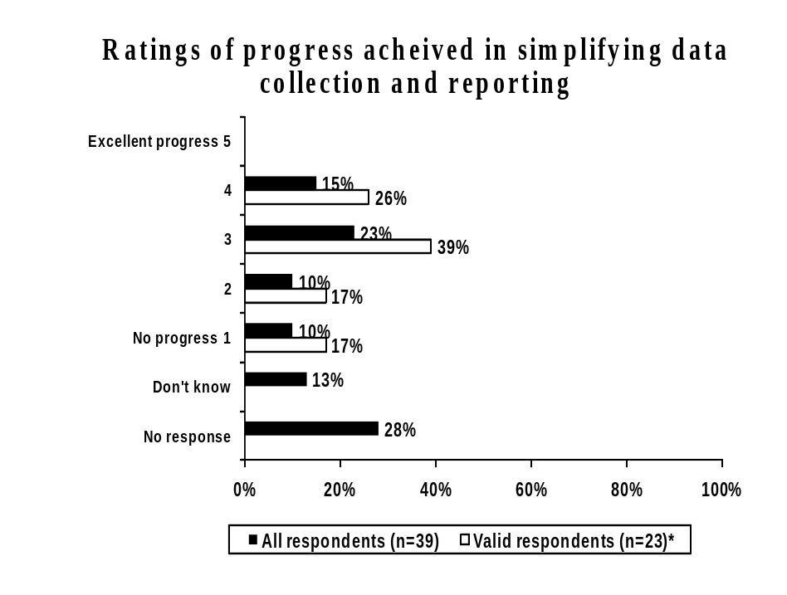
* Excludes “Don’t know” and “No response”

Respondents were asked to indicate why they provided their rating of progress made in regards to the recommendation to simplify data collection and reporting. Respondents that provided a low progress rating frequently mentioned the HOMES database was a complicated system and difficult to set up (2 respondents). See Table 13, below for a list of all responses provided.

Table 13
Why do you feel this way?*
Base: Respondents that provided a low progress rating (1 or 2 out of 5) for progress made in simplifying data collection and reporting | Number of Respondents (n=8)
HOMES database is a complicated system/difficult to set up | 2
Financial accountability/reporting has increased | 1
Client statistical reporting has decreased | 1
There is confusion when reporting turn-aways | 1
Have not participated in data collection | 1
Have not seen documentation to support this | 1
Needs to be some clarity to collection/input of data | 1
Need to improve some areas of reporting | 1
Don’t know/No response | 1
*Multiple mentions

Respondents that provided a moderate to high progress rating (n=15), most frequently indicated that good progress had been made or that the steps have been simplified (3 respondents). Other mentions included that the process has been started but has not been made more efficient as of yet (2 respondents), and that the wrong questions are being asked during data collection and exit surveys (2 respondents). See Table 14, below for a complete list of the responses provided.

Table 14
Why do you feel this way?*
Base: Respondents that provided a moderate or high progress rating (3, 4 or 5 out of 5) for progress made in simplifying data collection and reporting | Number of Respondents (n=15)
Good progress/steps have been simplified | 3
Process has been started but not made more efficient | 2
Data collection and exit surveys ask the wrong questions | 2
There is confusion when reporting turn-aways | 1
Reporting is the same as before | 1
Training on HOMES is provided by the province | 1
Needs to be some clarity to collection/input of data | 1
High turnover leads to too much time spent on training | 1
Exit surveys still need to be done annually (yearly audit) | 1
The government system seems to have difficulty accessing data | 1
Don’t know/No response | 4
*Multiple mentions

Respondents were asked if their shelter was collaborating with PFVBD to explore collaborative options to better meet the needs of women in need and women in crisis situations who are not abused and outside of Children and Youth Services women’s shelter program mandate. Thirteen percent (13%) of respondents indicated that their shelter was collaborating with PFVBD in this regard, while 56% indicated their shelter was not.

Nineteen percent of valid respondents (19%) or those that provided a response (n=27) indicated that their shelter was collaborating with PFVBD to explore collaborative options to better meet the needs of women in need and women in crisis who are not abused and outside of Children and Youth Services women’s shelter mandate. See Figure 21, below.

Figure 21
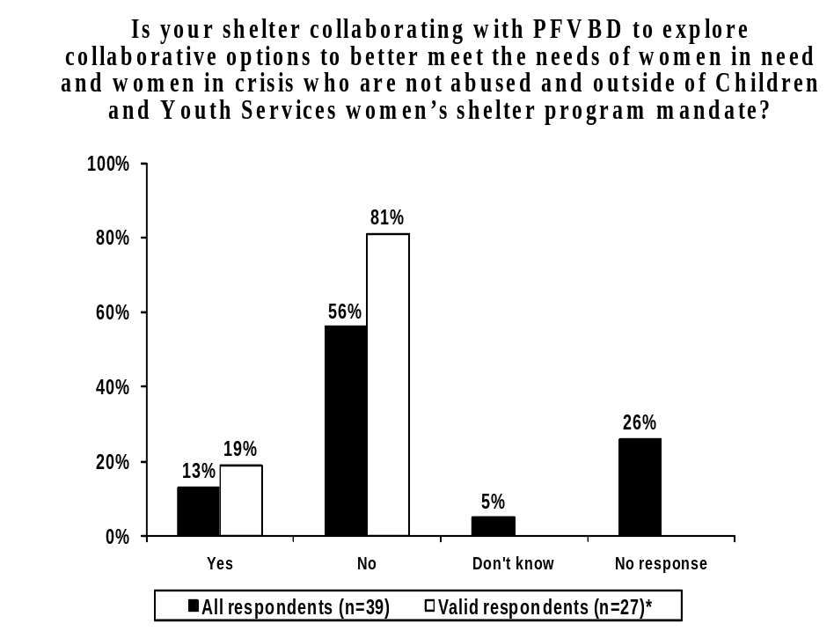
* Excludes “Don’t know” and “No response”

Respondents that indicated their shelter was not collaborating with PFVBD to explore collaborative options (n=22) were asked to indicate why they had not been involved. Nine respondents (n=9) reported that they have not been invited to participate in the collaboration process, while two (2) respondents stated they have collaborated with other agencies in this regard. See Table 15, below.

Table 15
Why have you not been involved?*
Base: Respondents whose shelters were not collaborating with PFVBD | Number of Respondents (n=22)
Have not been invited to participate | 9
Have collaborated with other agencies | 2
Focus is not second stage housing / breaking the cycle of violence | 1
Was not part of the committee | 1
Would need someone there to be involved | 1
Only serve women and children who have experienced family violence | 1
More services are being cut (rent supplement, welfare rates, housing) | 1
PFVBD does not recognize funding support that is needed (housing) | 1
Homelessness is a pervasive problem | 1
Don’t know/No response | 6
*Multiple mentions

As illustrated in Figure 22, below, almost two-thirds (64%) of respondents indicated that they feel they have the discretion and flexibility to grant extensions on length of stay for women in shelters, while 5% reported that they did not (refer to the footnote below for more detail regarding this recommendation). Thirty-one percent (31%) of respondents did not provide a response or were unsure in this regard.

Of the valid respondents or those that provided a response (n=27), the vast majority (93%) indicated that they feel they have the discretion and flexibility to grant extensions on length of stay.

Figure 22
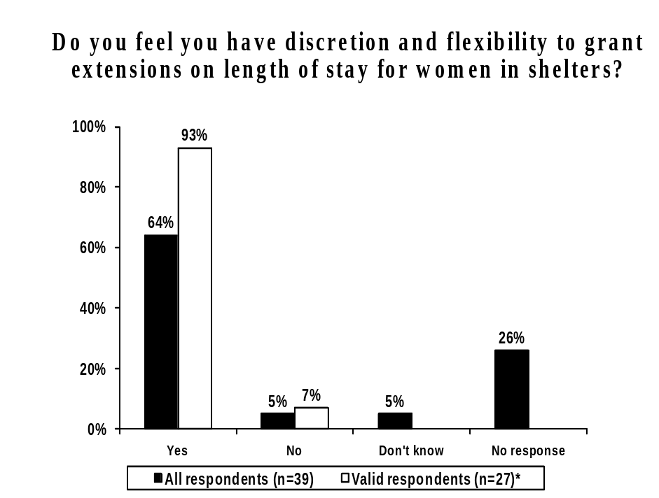
* Excludes “Don’t know” and “No response”

Respondents that indicated they did not feel they have the discretion or flexibility to grant extensions (2 respondents) were asked why they felt this way. One respondent each stated that their shelter numbers would be down at the end of the year, that they only have a fee for service agreement with the Provincial Government and the maximum stay is only 21 days.

Respondents were asked if PFVBD had raised the potential of additional support in order to address the challenges of communal living. Five percent (5%) of respondents indicated that PFVBD had raised the potential of additional support while 56% of respondents stated they had not. Thirty-nine percent (39%) of respondents did not provide a response or were unsure.

Eight percent (8%) of valid respondents or those that provided a response (n=24) indicated that PFVBD had raised the potential of additional support to address the challenges of communal living. See Figure 23, below.

Figure 23
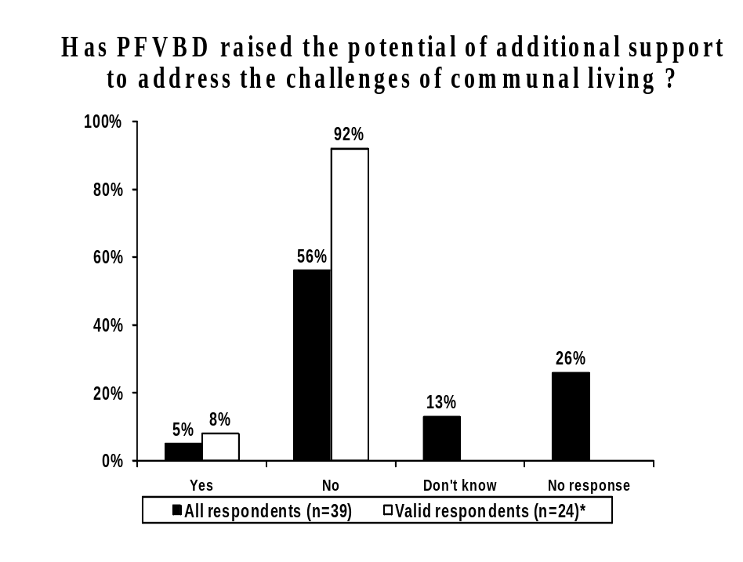
* Excludes “Don’t know” and “No response”

Those who indicated PFVBD had not, or were unsure if PFVBD had raised the potential of additional support in order to address the challenges of communal living (n=37) were asked if their shelter had raised this potential with PFVBD.

Eleven percent (11%) of respondents stated that they had raised the issue, while 51% reported that they had not.

Seventeen percent (17%) of valid respondents or those that provided a response (n=23) indicated that they had raised the potential of additional support in order to address the challenges of communal living. See Figure 24, below.

Figure 24
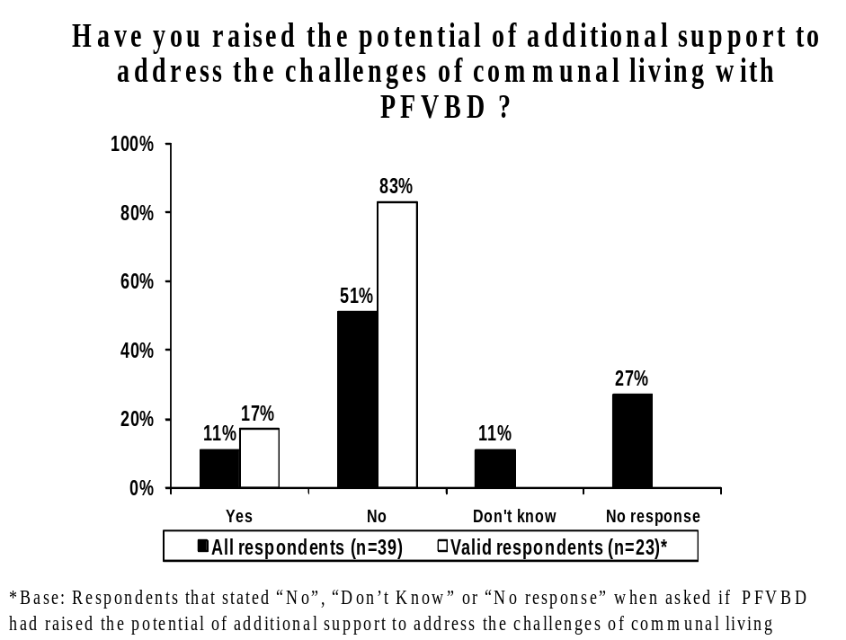
* Excludes “Don’t know” and “No response”

Respondents were then asked if they had actually received any additional support in order to address the challenges of communal living. Only five percent (5%) of respondents indicated that they had received additional support in this regard, while 64% of respondents stated they had not.

Only seven percent (7%) of valid respondents or those that provided a response (n=27) indicated that they had received any additional support. See Figure 25, below.

Figure 25
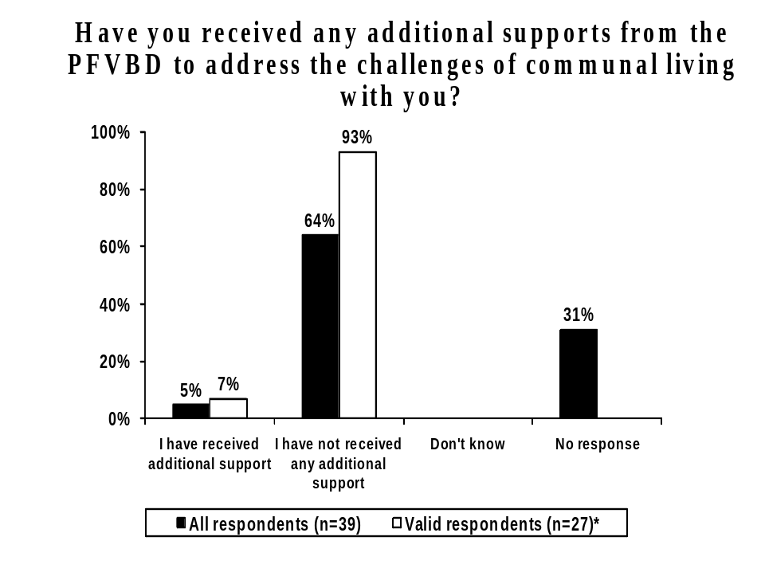
* Excludes “Don’t know” and “No response”

Those that had received additional support (2 respondents) were asked what additional supports they had received. One respondent each indicated they had received a childcare grant and extra community information for their staff.

When asked to rate the adequacy of these supports, one respondent provided a low adequacy rating, as the additional childcare is only available for a few hours per week, while the other respondent provided a moderate rating of adequacy for these supports.

Respondents were asked to indicate the accuracy of PFVBD in their assessment of operating pressures in their shelter. As illustrated in Figure 26, below, 10% of respondents provided a high rating of accuracy, while 15% provided a moderate rating of accuracy. Twenty-eight percent (28%) of respondents provided a low level of accuracy regarding PFVBD in assessing operating pressures in their shelter. Forty-six percent (46%) of respondents did not provide an accuracy rating.

More than half (53%) of valid respondents or those that provided a rating (n=21) provided a low accuracy rating for PFVBD in assessing the operating pressures within their shelter.

Figure 26
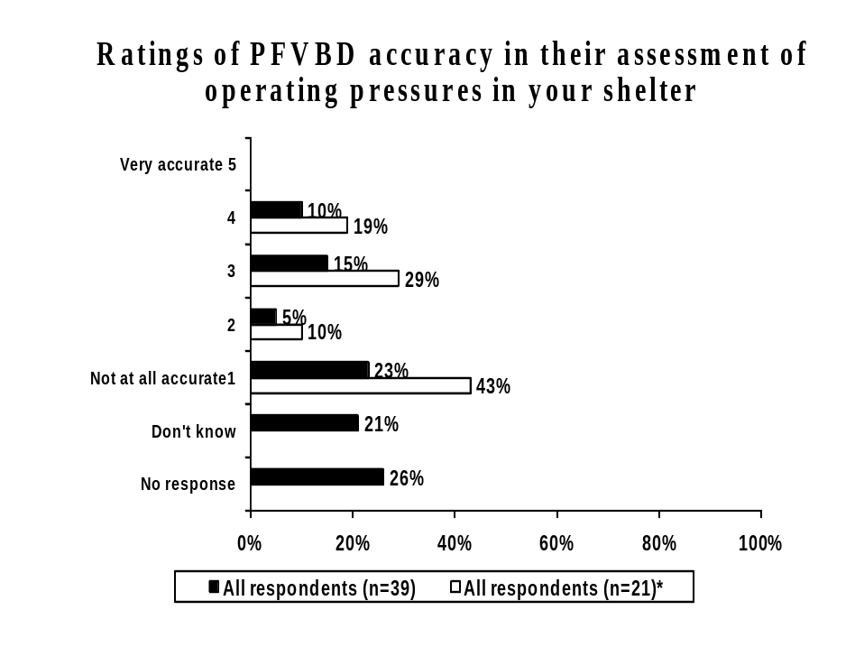
* Excludes “Don’t know” and “No response”

Respondents were asked to indicate why they provided their particular accuracy rating of PFVBD in assessing the operating pressures at their shelter. Respondents that provided a low level of accuracy (n=11) most frequently stated that shelters were underfunded (4 respondents) and that they have not been assessed by PFVBD (3 respondents). See Table 16, below.

Table 16
Why do you feel this way?*
Base: Respondents that provided a low accuracy rating (1 or 2 out of 5) of PFVBD assessing operating pressures at their shelter | Number of Respondents (n=11)
Shelters are underfunded/not funded/no funding increase | 4
There has not been an assessment by PFVBD | 3
PFVBD urges spending on children less than 6 years old to be a priority | 1
Dislikes the idea of women’s shelter as equivalent to daycare spaces | 1
We are an on-reserve shelter (unspecified) | 1
Don’t know/No response | 1
*Multiple mentions

Respondents that provided a moderate to high accuracy rating of PFVBD in assessing operating pressures at their shelter (n=15), most frequently stated that shelters are underfunded or not funded at all (2 respondents), while 6 respondents were unable to provide a reason for their rating. See Table 17, below.

Table 17
Why do you feel this way?*
Base: Respondents that provided a moderate or high accuracy rating (3, 4 or 5 out of 5) of PFVBD assessing operating pressures at their shelter | Number of Respondents (n=10)
Shelters are underfunded/not funded/no funding increase | 2
PFBVD is not aware of the issues | 1
Have not been able to allocate funds to priority areas | 1
Don’t know/No response | 6
*Multiple mentions

As depicted in Figure 27, below, 18% of respondents provided a high rating of training supports from the Province being effective in meeting the needs of shelter staff, while 21% provided a moderate effectiveness rating in this regard. Twenty-three percent (23%) of respondents provided a low effectiveness rating for the training supports from the province meeting the needs of staff, while 38% did not provide a rating.

Twenty-nine percent (29%) of valid respondents or those that provided a rating (n=24) rated the training supports from the province being highly effective in meeting the needs of shelter staff.

Figure 27
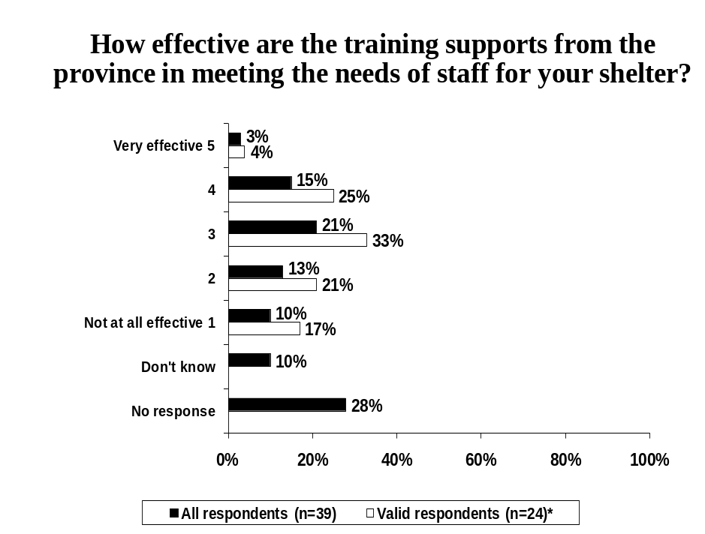
* Excludes “Don’t know” and “No response”

Respondents were asked to indicate why they provided their particular rating regarding the effectiveness of training supports from the Province meeting the needs of shelter staff. Respondents that provided a low rating of effectiveness (n=9), most frequently stated there is no training support provided (2 respondents), that there is a lack of funds allocated to training (2 respondents) or that it is too far or too expensive to travel to attend this training (2 respondents). See Table 18, below for a complete list of responses.

Table 18
Why do you feel this way?*
Base: Respondents that provided a low effectiveness rating (1 or 2 out of 5) of training supports from the Province meeting the needs of shelter staff | Percent of Respondents (n=9)
There is no training support | 2
Not enough money allocated | 2
Too far to travel for training/expensive to travel/can’t find relief | 2
Not aware of training opportunities | 1
Provide own training | 1
Training topics are strictly relevant to shelter/PFVBD contracts | 1
Don’t know/No response | 2
*Multiple mentions

Respondents that provided a moderate to high effectiveness rating (n=15), most frequently mentioned that it is too far or too expensive to travel to attend this training (4 respondents), while two respondents stated that opportunities for training are rare. See Table 19, below.

Table 19
Why do you feel this way?*
Base: Respondents that provided a moderate or high effectiveness rating (3, 4 or 5 out of 5) of training supports from the Province meeting the needs of shelter staff | Number of Respondents (n=15)
Too far to travel for training/expensive to travel/can’t find relief | 4
Few opportunities | 2
Have leadership funding | 1
Training topics are strictly relevant to shelter/PFVBD contracts | 1
Funding is available | 1
Staff attendance is mandatory/certification is kept up to date | 1
Don’t know/No response | 6
*Multiple mentions

Transitional Supports
Next, respondents were asked if their shelter had worked with PFVBD to identify opportunities and challenges in order to enhance effective outreach service delivery. Twenty-eight percent (28%) of respondents indicated that their shelter had, while one-third (33%) stated that their shelter had not identified these opportunities and challenges with PFVBD. Thirty-nine percent (39%) of respondents were unable to provide a response.

When considering valid respondents or those that provided a response (n=24), less than thirty percent (28%) had worked with PFVBD to identify opportunities and challenges in order to enhance effective outreach service delivery. See Figure 28, below.

Figure 28
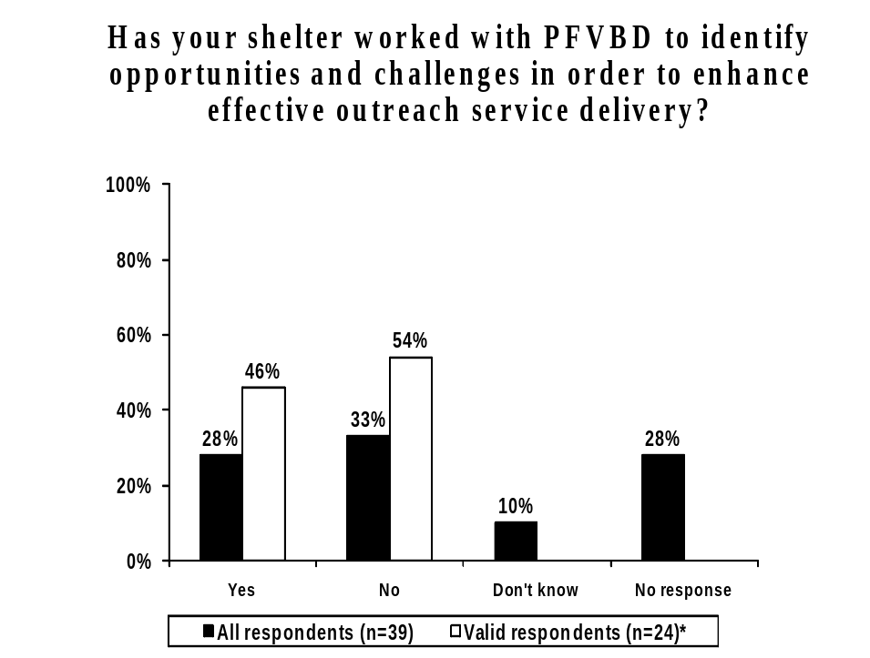
* Excludes “Don’t know” and “No response”

Respondents that had not worked with PFVBD to identify opportunities and challenges in order to enhance effective outreach service delivery (n=13) were asked why they had not done so. Two (2) respondents stated that the government provided funding for an outreach position, while another two (2) respondents stated that they have not had the opportunity to do so or had not received any communications in this regard. See Table 20, below for a complete list of responses.

Table 20
Why not?*
Base: Respondents that had not worked with PFVBD to identify opportunities and challenges in order to enhance effective outreach service delivery | Number of Respondents (n=13)
Government provided funding for outreach position | 2
Have not had the opportunity/have not received anything | 2
Participated with others to develop a guide for new outreach workers | 1
Not needed/have an outreach program already | 1
Shelter does not have outreach capacity | 1
More effective to work with other partners | 1
Tried to contact representative but was not helpful | 1
Don’t know/No response | 4
*Multiple mentions

Respondents were asked to indicate which areas their shelter has worked with PFVBD in order to identify ways to enhance specialized supports. Four (n=4) respondents stated that they worked with PFVBD regarding legal services, followed financial assistance (3 respondents) and counseling (3 respondents). Two respondents each worked in the areas of affordable housing and treatment. Seventeen (17) respondents stated they had not worked in any of the areas specified. See Figure 29, below.

Figure 29
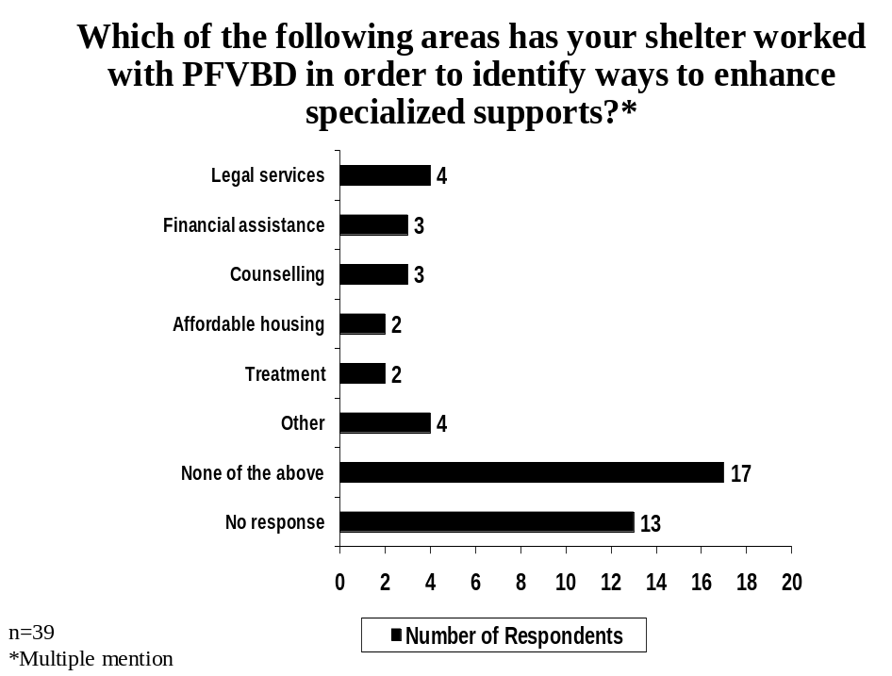

Respondents that mentioned they had worked in other areas (n=4) specified the areas of childcare (2 respondents), outreach (1 respondent), training opportunities (1 respondents) and arranged fees for a service agreement (1 respondent) as being the areas they had worked with PFVBD in order to enhance specialized supports.

Next, respondents were asked to indicate the areas in which their shelter has received information and updates from PFVBD. Six respondents (6) reported that they had received information and updates about financial assistance. Two respondents each received information and updates in the areas of legal services, counseling and affordable housing, while 17 respondents stated that they had not received information or updates in any of the areas mentioned. See Figure 30, below.

Figure 30
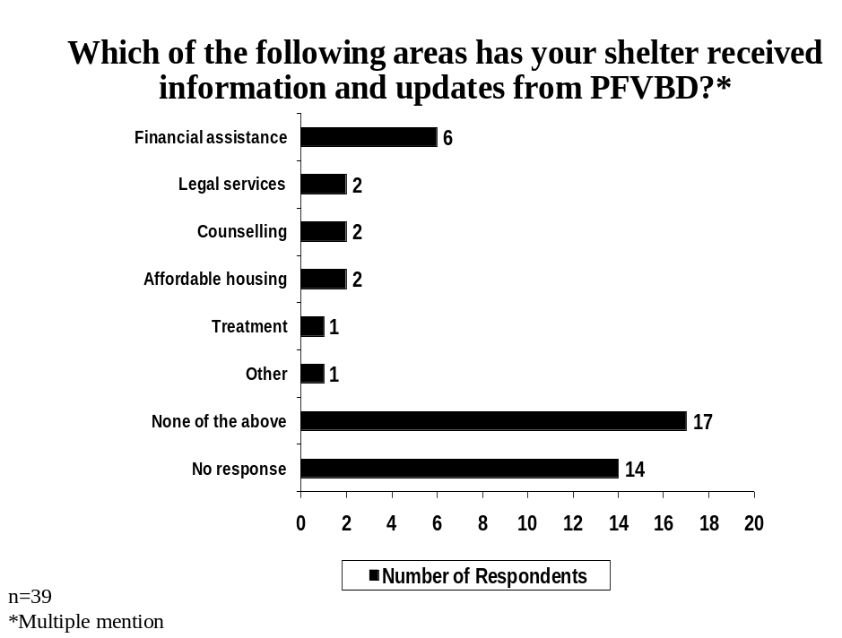

Respondents that reported they had received information and updates from PFVBD in other areas (n=2) specifically mentioned childcare (1 respondent) and outreach (1 respondent) as being the areas they had received information and updates from PFVBD.

Complex Needs
As illustrated in Figure 31, below, only 8% of respondents provided a high or moderate rating of satisfaction (3, 4 or 5 out of 5) regarding the support received from the government for cross sector training to better meet the multiple and complex needs of clients, while 46% provided a low rating of satisfaction. Forty-one percent (41%) of respondents did not provide a satisfaction rating.

When considering only valid respondents or those that provided a response (n=23), only 13% of respondents provided a high satisfaction rating.

Figure 31
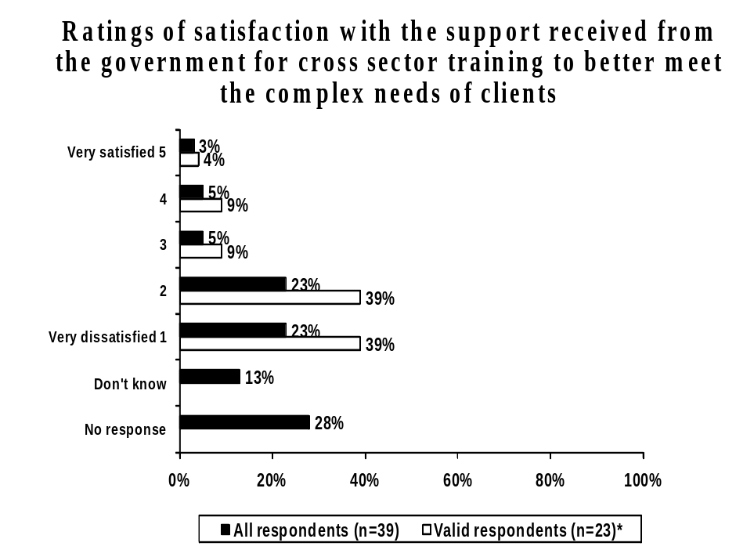
* Excludes “Don’t know” and “No response”

Respondents were asked to indicate why they provided their satisfaction rating regarding support received from the government for cross sector training. Respondents that provided a low satisfaction rating (n=18) most frequently mentioned the lack of awareness and/or support for shelter staff (7 respondents), while six (6) respondents stated that training is rare unless organized internally or locally. See Table 21, below for a complete list of responses.

Table 21
Why do you feel this way?*
Base: Respondents that provided a low satisfaction rating (1 or 2 out of 5) regarding the support received from the government for cross sector training. | Number of Respondents (n=18)
Nothing is happening for shelter staff/not aware of any supports | 7
Training is rare unless organized internally/locally | 6
Funds not available/no funding | 2
No attention focused on support in rural areas | 1
Don’t’ know/No response | 3
*Multiple mentions

Respondents that provided a moderate or high rating of satisfaction (n=5) mentioned training being provided for the staff (1 respondent), that some improvements had been made (1 respondent) and that the ACWS gave support to executive directors (1 respondent) as reasons for rating of satisfaction.

Children/Safe Visitation
Respondents were asked to provide a rating of satisfaction regarding the support received from PFVBD in meeting the diverse needs of children and youth in their shelter. Eighteen percent (18%) of respondents provided a high rating of satisfaction, while 23% provided a moderate rating. Eighteen percent (18%) of respondents provided a low rating of satisfaction, while 41% of respondents did not provide a rating.

Thirty percent (30%) of valid respondents or those that provided a rating (n=23) indicated they were satisfied (4 or 5 out of 5) regarding the support received from PFVBD in meeting the diverse needs of children and youth in shelters. See Figure 32, below.

Figure 32
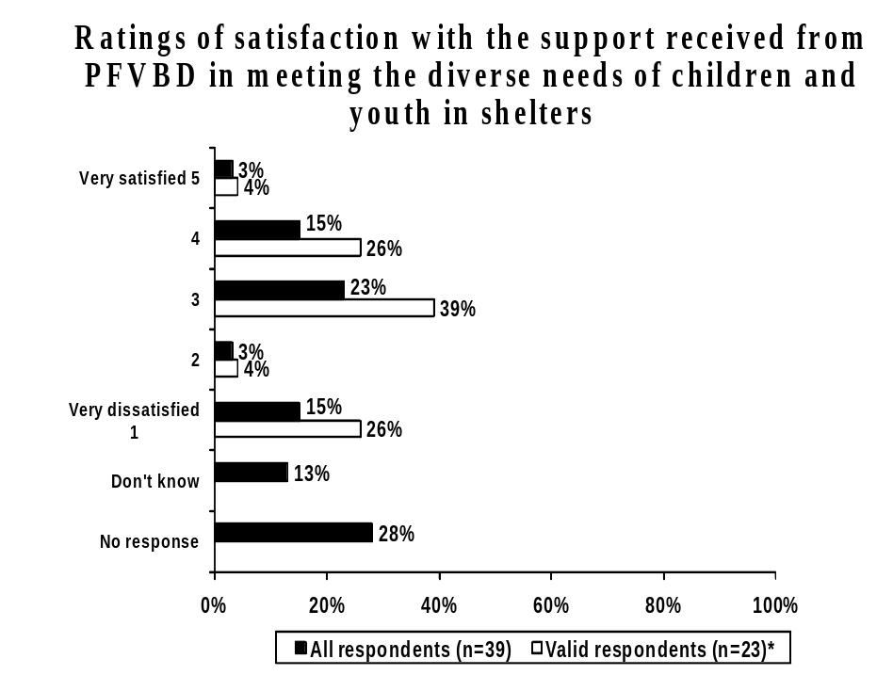
* Excludes “Don’t know” and “No response”

Respondents were asked to indicate why they provided their particular rating of satisfaction regarding support received from PFVBD in meeting the diverse needs of children and youth in shelters. See Table 22, below, for the single mentions made by respondents that provided a low satisfaction rating (n=7)

Table 22
Why do you feel this way?*
Base: Respondents that provided a low satisfaction rating (1 or 2 out of 5) of support received from PFVBD in meeting the diverse needs of children and youth in shelters | Number of Respondents (n=7)
There has been no support | 1
No funding for on-reserve shelters | 1
Don’t receive support from PFVBD (receive money elsewhere) | 1
No support for qualified staff | 1
Don’t know/No response | 3
*Multiple mentions

Respondents that provided a moderate to high satisfaction rating (n=16), most frequently reported they had received grants or increased funding in this regard (6 respondents). See Table 23, below.

Table 23
Why do you feel this way?*
Base: Respondents that provided a moderate or high satisfaction rating (3, 4 or 5 out of 5) of support received from PFVBD in meeting the diverse needs of children and youth in shelters | Number of Respondents (n=16)
We received several grants/more funds made available | 6
PFVBD brought new initiatives that would allow for an increase in staff | 1
There has been no support | 1
We are engaged in setting up childcare | 1
Don’t know/No response | 7
*Multiple mentions

Respondents were asked to indicate their agreement with the statement “Collaborative efforts to ensure safe visitation and exchange have been advanced”. Fifteen percent (15%) of respondents provided a high rating of agreement, while 13% provided a moderate agreement rating. Twenty-three percent (23%) of respondents disagreed with the statement, and close to half (49%) of all respondents did not provide a rating.

Forty-five percent (45%) of valid respondents or those that provided a rating (n=20) stated a high level of agreement with this statement regarding safe visitation and exchange. See Figure 33, below.

Figure 33
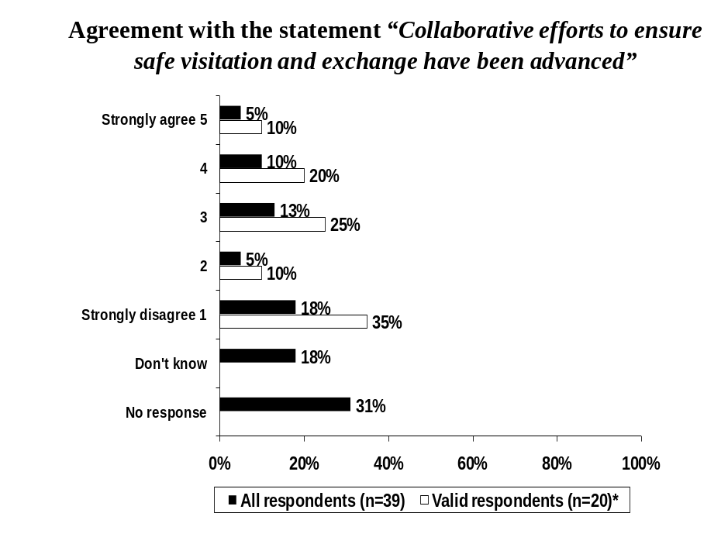
* Excludes “Don’t know” and “No response”

Respondents were asked to indicate why they provided their rating of agreement with the statement “Collaborative efforts to ensure safe visitation and exchange have been advanced”. Respondents that provided a low rating of agreement (n=9) most frequently indicated that there has been no progress or opportunity to access safe visitation sites in their area (2 respondents). See Table 24, below.

Table 24
Why do you feel this way?*
Base: Respondents that provided a low level of agreement (1 or 2 out of 5) with the statement “Collaborative efforts to ensure safe visitation and exchange have been advanced” | Number of Respondents (n=9)
No progress/no opportunity to access safe visitation sites in our area | 2
Have not been included/recognized in collaborations | 1
Don’t believe it is the shelters responsibility to provide safe sites | 1
There is a safe visitation site in our community | 1
Progress has been made (unspecified) | 1
Lack of sustainable funding | 1
Criteria for access to the program is too limiting | 1
Don’t know/No response | 2
*Multiple mentions

Respondents that provided a moderate to high rating of agreement with the statement (n=11), most frequently indicated that there is a safe visitation site within their community (4 respondents). See Table 25, below.

Table 25
Why do you feel this way?*
Base: Respondents that provided a moderate or high level of agreement (3, 4 or 5 out of 5) with the statement “Collaborative efforts to ensure safe visitation and exchange have been advanced” | Number of Respondents (n=11)
There is a safe visitation site in our community | 4
Have not been included/recognized in collaborations | 1
Have not seen anything | 1
Safe visitation sites are being funded across the Province | 1
Don’t know/No response | 4
*Multiple mentions

Prevention/Education/Intervention
As depicted in Figure 34, respondents were asked to rate the progress made regarding the recommendation to build awareness and provide information about the services and supports available in women’s shelters and through the larger community network to prevent and respond to family violence.

Only 8% of respondents indicated excellent progress had been made while one-third (33%) felt moderate progress had been achieved. Eighteen-percent (18%) of respondents felt little progress had been made in this regard, while 41% of respondents did not provide a rating.

When considering only valid respondents or those that provided a response (n=23), thirteen percent (13%) of respondents indicated that excellent progress has been made in building awareness about the services and supports available in women’s shelters and through the larger community.

Figure 34
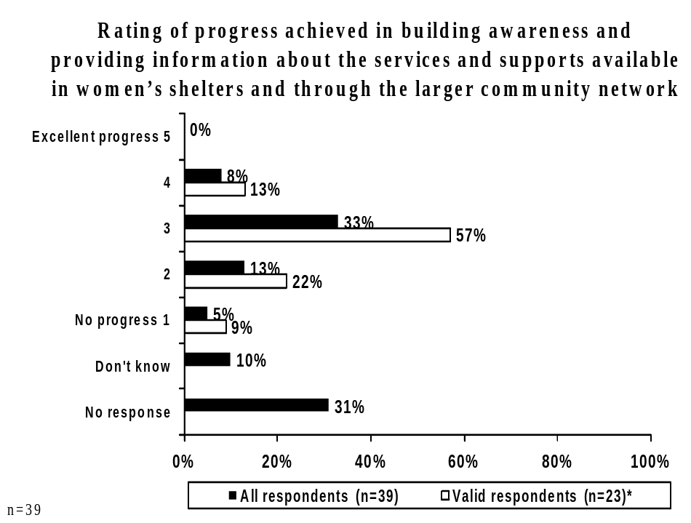
* Excludes “Don’t know” and “No response”

Respondents were asked to indicate why they had provided their rating of the progress made in building awareness and providing information about the services and supports available. See Table 26, below, for reasons provided by respondents that provided a low progress rating (n=7).

Table 26
Why do you feel this way?*
Base: Respondents that provided a low progress rating (1 or 2 out of 5) of building awareness and providing information about the services and supports available | Number of Respondents (n=7)
There is a provincial telephone line available | 2
Prevention and awareness is more focused on government services | 1
Would be beneficial to be aware enough to know to call shelters | 1
Not a lot of information/accurate information available | 1
Telephone line is not effective in connecting clients to shelters | 1
Don’t know/No response | 3
*Multiple mentions

Respondents that provided a moderate to high progress rating in this regard (n=16), most frequently indicated that the work had been done by the ACWS and individual shelters (2 respondents) or that the shelters advertise through the media (2 respondents). See Table 27, below.

Table 27
Why do you feel this way?*
Base: Respondents that provided a moderate or high progress rating (3, 4 or 5 out of 5) of building awareness and providing information about the services and supports available | Number of Respondents (n=16)
This work has been done by ACWS and individual shelters | 2
Advertise through media (radio, posters, ads) | 2
Needs to be a greater recognition of pioneer work done by shelters | 1
Continue to build educational components into schools/communities | 1
Shelters seem to be the last resource method | 1
No increase from PFVBD | 1
On-reserve shelters have access to information and networking | 1
PFVBD took responsibility for awareness/created help lines | 1
Cumbersome to approach each organization separately | 1
Don’t know/No response | 7
*Multiple mentions

Priorities for New or Enhanced Services
Finally, respondents were asked to rate the progress that has been achieved in addressing new and enhanced client services. The priorities with the highest mean ratings of progress achieved included enhanced and enriched childcare support and child-specific programming with a mean of 2.91 out of 5, followed by enhanced parenting, life skills and specialized child support programs (mean=2.46). The priority area with the lowest mean progress rating was in regards to increased support for transportation (mean=1.86). See Table 28, below.

Table 28
Progress Made in Priority Areas in New and Enhanced Client Services
Percent of Respondents
(n=39)
 | No Progress  (1) | 2 | 3 | 4 | Excellent Progress  (5) | Don’t know/ No Response | Mean
Enhanced and enriched childcare support and child-specific programming | 5 | 15 | 18 | 21 | -- | 41 | 2.91
Enhanced parenting, life skills and specialized child support programs as well as recreational programming | 23 | 10 | 8 | 18 | 3 | 39 | 2.46
Safe visitation and exchange supports | 21 | 18 | 8 | 10 | 5 | 39 | 2.38
Access to affordable and effective legal support services | 21 | 13 | 15 | 5 | 3 | 44 | 2.23
Improved access to safe, affordable housing | 18 | 26 | 15 | 3 | -- | 39 | 2.04
Increased capacity (training, staffing) to provide one-on-one support to women and children with multiple and complex needs, including mental health and addictions issues | 26 | 15 | 10 | 3 | 3 | 44 | 1.95
Increased support for transportation | 23 | 15 | 15 | -- | -- | 46 | 1.86

ACWS Shelter Directors In-Depth Interviews

  - STUDY BACKGROUND
In July 2009, Banister Research & Consulting Inc. (Banister Research) was contracted by the Alberta Council of Women’s Shelters (ACWS) to conduct in-depth interviews with the directors of the various women’s shelters in the province of Alberta. These shelter directors represented a mix of shelters located in both urban and rural areas as well as emergency versus second stage housing versus senior’s classifications. The intent of the in-depth interviews was to gather feedback from shelter directors to their level of participation and involvement the consultations held in the development of the Premier’s Roundtable on Family Violence and Bullying Report (2004) and the Women’s Emergency Shelter Program Review: Final Report (2006). The interviews also assessed director’s perceptions and opinions of the progress that has been achieved regarding the recommendations outlined in the above-mentioned reports.

Specifically, the objectives of the in-depth interviews with shelter directors included:
- To determine the most important issues and challenges faced by shelter directors to their facility’s operation;
- To determine if shelter directors participated in any of the consultations held regarding the development of the 2004 Premier’s Roundtable on Family Violence and Bullying Report and to assess what progress, if any, has been made with regards to the recommendations outlined in this report;
- To determine which, if any, of these recommendations require additional attention;
- To determine if shelter directors participated in any of the consultations held regarding the development of the 2006 Women’s Emergency Shelter Program Review: Final Report and to assess what progress, if any, has been made with regards to the recommendations outlined in this report;
- To determine which, if any, of the 2006 Program Review recommendations require additional attention; and
- To determine if shelter directors were receiving adequate financial support from the Prevention of Family Violence and Bullying Division (PFVBD).

  - METHODOLOGY
All components of the project were designed and executed in close consultation with the ACWS (the Client). A detailed description of each task of the project is outlined in the remainder of this section.

Project Initiations and Questionnaire Design
At the outset of the project, a list of the potential shelter directors in Alberta was compiled and reviewed. The survey instrument used to conduct the in-depth interviews was modeled primarily after the 2009 ACWS Progress Report Web Survey with additional questions to gather more specific and in-depth information. A copy of the final questionnaire is provided in Appendix B.

Survey Populations and Data Collection
The in-depth interviews were completed from July 29th to August 6th, 2009. Respondents were pre-booked to complete the survey, by telephone, with an Associate of Banister Research and required between 30 minutes to 1 hour to complete each interview. A total of nine (9) shelter directors were interviewed representing three (3) shelter types (emergency, second stage and seniors) serving the needs of urban or rural residents.

Readers of this report should be cautioned as to the interpretation of results obtained from the in-depth interviewing process. These results are qualitative in nature and they while provide valuable insights, they cannot be considered statistically representative.

SUMMARY OF FINDINGS
The following section provides a summary of the key findings for the ACWS Shelter Directors Survey.

General Shelter Information
    - Important Issues and Concerns
To begin the interview, respondents were asked to indicate the most important issues and/or challenges they have experienced in terms of the maintenance and operation of their organization’s facility and programs. Many respondents stated that they were concerned about the lack of funding their organization receives to support operating costs in particular.

While expressing concerns about the need for additional funding in general, specific issues highlighted by respondents included:
- Shelters often have to fundraise on their own to support the services they provide;
- Current funding for operations is inadequate let alone finding funds to support the ongoing maintenance of the facility;
- There is very little support for women leaving the shelter and in need of affordable housing;
- There are concerns about possible government cutbacks;
- Increased funding is needed to support many second stage programs, in addition to housing;
- More funding is required to retain, hire and train staff; and
- Additional funding is required to support various out-reach programs in the community.

Respondents cited specific issues relating to the maintenance of their present facility. Some of the specific issues were related to general maintenance of the facility (i.e. the building is run down, poor heating and air conditioning, has mold issues, etc.), the need for expanded office space in the shelter, the need for more basic appliances and amenities (i.e. stoves), the need for more capacity or more beds and the need for the an entirely new facility in one case.
Many respondents identified staffing issues as being a major concern of their organization, particularly those located in the rural areas. The lack of qualified staff, an inability to pay competitive wages to stay competitive (including the provision of health benefits and mileage), and the need to hire specialized staff including management, housekeepers and maintenance workers were specifically mentioned.

Other important issues and concerns mentioned by respondents included:
- The lack of affordable housing available for single women;
- The stigma attached to women’s shelter services within the community;
- The lack of specific resources within their community (i.e. law firms, etc.);
- A shortage of treatment centres for those with complex needs (i.e. those suffering addictions or mental health related issues);
- Conflicts that exist between board members and shelter staff preferring different methods implemented to achieve the shelter’s goals; and
- Recognition that seniors are also in need of shelter services.

    - Resolving Important Issues and Concerns
Next, shelter directors were asked to specify solutions to resolve these important issues and concerns. The majority of respondents indicated that additional funding would do most to help resolve the issues and concerns. Other potential solutions mentioned by respondents included:
- Developing a province-wide second stage program;
- Building more treatment centres for those with complex needs (i.e. addictions);
- Developing a plan to help women that require assistance that is outside the mandate of the shelter;
- Lobby the government for increased support;
- Altering the way funding contracts are negotiated to reflect the total costs associated with operating the shelters;
- Changing the eligibility criteria of women applying for low income housing to include single women;
- Strengthening the relationships that exist between shelter board and staff members; and
- Support the needs of seniors that require shelter services.

Premier’s Roundtable on Family Violence and Bullying Report

7.2.1 Participation in the Premier’s Roundtable
Respondents were asked to respond to a series questions regarding the Premier’s Roundtable on Family Violence and Bullying Report (2004).

When asked if they had participated in any of the consultations held in the development of the Premier’s Roundtable on Family Violence and Bullying Report (2004), the vast majority of respondents indicated they had. While one shelter director that had not taken part in the consultation, they were aware of the recommendations. Another respondent indicated they were not aware of any of the recommendations published in the report, as they had not been working with women’s shelters at that time.

7.2.2 Progress of the Premier’s Roundtable
Next, respondents aware of the recommendations made in the report were asked to rate the progress achieved in this regard, using a scale from 1 to 5, where 1 means “no progress” and 5 means “excellent progress”. Many shelter directors provided progress a rating of 3 out of 5, while others provided a rating of 2 out of 5. One (1) respondent was unable to provide a response.

Respondents that were aware of the roundtable recommendations were asked to specify why they provided their rating of progress. The majority of respondents felt that while progress had been made in some areas, it was lacking in other areas. Areas where progress had been achieved included:
- Children’s issues, such as bullying;
- Social changes and collaborative community response areas;
- Funding of basic shelter necessities, such as grocery expenses;
- The implementation of the Community Incentive Fund (CIF);
- Improved regional coordination of shelters;
- Training sessions for prosecutors and judges;
- Women’s shelter programs becoming more victim focused; and
- Allocation of staff to family violence.

Areas where progress was lacking included issues related to the province increasing awareness and providing leadership, the lack of second stage shelters or programs and the continued lack of services, support and funding for shelters. Other reasons progress had not been achieved included:
- The overall accountability of those responsible for implementing the recommendations provided in the report;
- While progress has been made in regarding to children’s issues, progress regarding women’s issues remain unchanged;
- The need to develop a separate commission for violence against women through an entity separate from PFVBD;
- Changes to the legal system in order to ensure that offenders are punished;
- Improvements in government legislation (i.e. Child Family Act, Protection Against Family Violence Act);
- Bureaucratic changes and organizational restructuring have not translated into progress;
- Police need to be held accountable when improper investigations of domestic violence cases (specifically in the rural areas);
- Too many meetings but not enough action;
- The lack of progress for transitional supports (i.e. affordable housing); and
- The Emergency Protection Order not being a viable option for women, as they are not safe to stay in their own residence.

7.2.3 Areas that Require Increased Attention and Effort
When asked if there were any recommendations or areas that required more attention to increase progress, respondents most frequently mentioned:
- Programs and supports for second stage housing;
- The services and supports section of the report;
- The section of the report regarding accountability;
- Increasing provincial leadership;
- Developing a specific program or organization to address violence against women (similar to an AADAC like structure);
- Changes to the legal system in order to ensure that offenders are punished;
- Update to reflect the current need as opposed to what was needed in 2004;
- Recognize that domestic violence is not a gender neutral issue (predominately male perpetuated);
- Ensure that other governmental agencies are educated about issues pertaining to violence against women;
- Meet the needs of shelter users over the age of 50; and
- Recognize that there are some men have suffered abuse and require programs and services for complex needs.

Next, shelter directors were asked what could be done to ensure that the recommendations of the Premier’s Roundtable on Family Violence and Bullying Report (2004) are met. Respondents frequently mentioned re-visiting the roundtable or creating a follow-up report to Albertans, while others stated the government should be held accountable by ACWS to make the recommendations a priority. Other shelter directors questioned the relevancy of the issues raised in 2004 and suggested refocusing on the issues at present. Other suggestions included reviewing policy in general to ensure that social programs receive the appropriate funding, developing an inter-governmental committee to work with non-for-profits to implement the roundtable recommendations to determine priorities moving forward.

Respondents were asked if they had any additional comments regarding the roundtable. Some respondents mentioned they were pleased with the current contract negotiations that are occurring. Other comments included:
- Pleased that wages for shelter staff have increased;
- The roundtable needs to be revisited and re-evaluated;
- The fleeing violence fund outlined in the roundtable is very effective;
- Inactivity of the government is to blame for the lack of progress, not the PFVBD;
- Perceptions that Child Welfare often pressures women to enter shelters with the threat of taking their children away and more training is needed for Child Welfare staff regarding violence against women;
- Pleased that women’s shelters are part of a pilot project to house women previously discharged from the shelter; and
- A general need for the roundtable recommendations to be implemented.

Women’s Emergency Shelter Program Review

7.3.1 Participation in the Women’s Emergency Shelter Review
Respondents were asked to respond to a series questions regarding the Women’s Emergency Shelter Program Review: Final Report (2006).

When asked if they had participated in any of the consultations held in the development of the Women’s Emergency Shelter Program Review: Final Report (2006), the vast majority of respondents indicated that they had not participated in the project.

None of the respondents that had not taken part were able to recall any of the recommendations of the Women’s Emergency Shelter Program Review: Final Report (2006). When these respondents were asked to indicate why they were not aware of the recommendations, the vast majority stated that they were unable to remember the document. Other responses included that they had just started working with women’s shelters at the time the report was released, while one respondent stated that they did not think the report would apply to second stage shelters.

7.3.2 Progress of the Women’s Emergency Shelter Review
The two respondents that had taken part in the consultation leading up to the Women’s Emergency Shelter Program Review: Final Report (2006) were asked to rate the progress achieved since the consultation, using a scale from 1 to 5, where 1 means “no progress” and 5 means “excellent progress”. One respondent provided a rating of 3 out of 5, while the other provided a rating of 2 out of 5.

When was asked to specify why they felt this way, respondents indicated overall, the recommendations were too broad. They noted that while some changes have been made, including increased staff wages and the opening of additional beds, progress was lacking in the areas of transportation, increasing affordable and secondary housing. Other areas of improvement noted included helping those with mental health and addictions issues, improving reporting, addressing contract issues and ensuring that shelter turn-aways are looked after. Other areas of need included increasing access to lawyers for rural shelters and increasing the number of management positions at the shelter.

7.3.3 Areas that Require Increased Attention or Effort
When those that had taken part in the consultation leading up to the Women’s Emergency Shelter Program Review: Final Report (2006) were asked if there were any recommendations or supports that required more attention or effort, respondents mentioned transportation to and from the shelter, affordable housing issues and addressing the needs of people suffering from addictions. Other recommendations and supports that required additional attention included:
- Programs to prevent violence against women at the grass roots level;
- Addressing complex needs (i.e. cultural issues);
- Providing legal aid in rural areas; and
- Providing safe visitation.

Respondents were asked what could be done to ensure that the recommendations of the Women’s Emergency Shelter Program Review: Final Report (2006) are met. One respondent mentioned that a follow-up report should be completed to ensure that the province is being held accountable to the original objectives of the report. The other respondent mentioned that resources were needed to ensure the government does not cut funding because of the poor economic climate.

All respondents were then asked if they had any additional comments regarding the Women’s Emergency Shelter Program Review: Final Report (2006). Specific comments included:
- The report needs to be revisited;
- Recommendations made in the program review are very useful;
- With the number of reports and other publications to review, it is hard to keep up to date;
- Not all shelters were consulted and there is poor communication with shelters; and
- In general, when any review is completed, the results are beneficial.

Support from the Prevention of Family Violence and Bullying Division (PFVBD)

Respondents were asked if they were receiving adequate financial support from the Prevention of Family Violence and Bullying Division (PFVBD). The majority of respondents indicated that they were not receiving adequate financial support from PFVBD while select respondents reported that they were.

Respondents that indicated they were receiving enough financial support from PFVBD stated that they had recently received increases in funding though more funding is required to cover staffing (providing benefits, additional positions), cost of living increases and the special needs of rural shelters (travel and training costs).

Amongst those that indicated they do not receive enough financial support from PFVBD many stated their shelter is not fully funded and they need to fundraise to operate and to cover transportation costs specifically. Other reasons sited for these shortfalls included:
- Funds are needed to pay for annual audits;
- The current formula used to determine funding is inefficient;
- Rising insurance costs take up a large proportion of the budget;
- Increases are required to train, recruit and retain staff; and
- Do not receive any funding from PFVBD (only receive funding from the Alberta Seniors government branch).

Additional Comments
Finally, respondents were given the opportunity to provide additional comments regarding the operation of their shelter. Many commented that while some progress has been made on the various recommendations more needs to be done, specifically in relation to increased funding and support for staff (wage increases, specific types of employees). Other comments included:
- Receive great support from the surrounding community to keep the shelter operating;
- There is a need to review the 21-day policy in emergency shelters (stay should be extended to a minimum of 6 weeks to a maximum of 90 days);
- The shelter is very busy and currently doing well in terms of client service delivery;
- More resources are needed to support immigrant women with unique needs (i.e. ESL training).

APPENDIX A
PROGRESS REPORT SURVEY INSTRUMENT

Progress Report on Government Recommendations Relating to Shelters

In 2004, the Premier’s Roundtable on Family Violence and Bullying, Finding Solutions Together made several recommendations concerning shelter services. In 2006, Alberta Children and Youth Services made further recommendations in the Women’s Emergency Shelter Program Review: Final Report.

ACWS is now preparing a progress report on both sets of recommendations. Our information will come from a survey of shelter directors, board members and staff as well as community stakeholders. Your participation in this survey is very important and greatly appreciated. Please take the time to respond to the following questions.

All responses will be collected and analyzed by Banister Research (an independent firm) to ensure the confidentiality of your feedback and the objectivity of the analysis. All information you provide is protected under the provincial Freedom of Information and Protection of Privacy Act. All answers are strictly confidential and will remain anonymous.

- What is your current position/job description within your organization?
□ I am a shelter director
□ I am a shelter staff person
□ I am a shelter board member
□ Other

Part 1: Premier’s Roundtable on Family Violence and Bullying

The Premier’s Roundtable on Family Violence and Bullying report can be found on the ACWS website:
http://www.acws.ca/documents/rpt_opfvb_finding_solutions_high.pdf

 
Recommendation: Establish a single, cross-sector entity for province-wide leadership

One of the top priorities was the need for a single, cross-sector agency to increase the profile, coordinate and provide province-wide leadership in addressing issues related to family violence and bullying. As a first step, a Prevention of Family Violence and Bullying Advisory Committee will be established. Members of the Committee will reflect a diverse range of geographic, community and service perspectives, as well as representatives from the Aboriginal Advisory Committee, the Ethno-cultural Working Group and the Youth Secretariat. The Committee will develop options for the structure and responsibilities of a single entity and provide advice to the provincial government on implementation of this report. The Executive Director for the Prevention of Family Violence will provide support to the single entity and ensure coordination with government and community partners. (Page 15)

- How would you rate the progress that has been made on the above recommendation?

No Excellent Don’t
Progress Progress Know
1 2 3 4 5 99

- Why do you feel this way?

Recommendation: Provide additional support to families escaping family violence.

Transition funding is an important way of supporting families escaping violent situations until they are able to get established in a new situation. Steps have been taken to streamline the process and respond quickly to the needs of families escaping family violence. (Page 20)

- From your perspective, were additional supports provided to families escaping family violence since the Roundtable report?

□ Yes □ No (skip to Q. 6) □ Don’t know (skip to Q. 6)

- If yes, please rate the effectiveness of these additional supports to families:

Not at all Very Don’t
Effective Effective Know
1 2 3 4 5 99

- Why do you feel this way?

- Has the process been streamlined and/or improved for families escaping violence?

□Yes □No (skip to Q. 9) □Don’t know (skip to Q. 9)

- If yes, please rate the effectiveness of the streamlined process:

Not at all Very Don’t
Effective Effective Know
1 2 3 4 5 99

- Why do you feel this way?

- Recommendation: Expand access to safe accommodations: Work is underway to review current policy on funding for prevention of family violence initiatives including shelter programs and to establish criteria for funding new emergency safe housing options on a priority basis. The new policy will establish guiding principles and clear criteria for funding allocations and will take into account best practices and needs across the province. (Page 20)

- How would you rate the progress made on a new policy on funding allocations that takes into account best practices and needs across the province.

No Excellent Don’t
Progress Progress Know
1 2 3 4 5 99

- Why do you feel this way?

- Recommendation: Expand access to safe accommodations: In addition to the need for safe accommodation in emergency situations, transitional (or second stage) housing is often a need for individuals and families ready to leave emergency housing. Through the local community planning process, municipalities are encouraged to identify the need for transitional housing and to initiate transitional housing projects based on their needs. (Page 20)

- How would you rate the progress that has been made in your local community to expand access to safe second stage accommodations?

No Excellent Don’t
Progress Progress Know
1 2 3 4 5 99

- Why do you feel this way?

Recommendation: Expand support available to victims of family violence and abuse: The Victims of Crime Fund is designed to assist organizations that help victims of crime during their involvement with the criminal justice system. Many of these organizations deal with victims of family violence. In the next two years, an additional $1.6 million will be allocated from the Victims of Crime Fund to support victims, including victims of family violence. (Page 20)

- Has your agency applied to the Victims of Crime Fund for funding?

□Yes □No (skip to Q. 16) □Don’t know (skip to Q.16)

- Was your agency successful in obtaining funding from the Victims of Crime Fund?

□Yes □No (skip to Q. 16) □Don’t know (skip to Q. 16)

- The Victims of Crime Fund also provides financial benefits for any physical or emotional injury as a direct result of being a victim of violent crime. How would you rate the effectiveness of this fund for individual women using your agency’s services?

Not at all Very Don’t
Effective Effective Know
1 2 3 4 5 99

Thank you for your time and effort in completing this survey. Your feedback is greatly appreciated.

Part 2: Women’s Emergency Shelter Review Program:
Final Report

The Women’s Emergency Shelter Review Program report can be found on the ACWS website:
http://www.acws.ca/documents/WomensEmergencyShelterProgramReview2006.pdf

Affordable, Safe, Suitable Housing:

Recommendation: Conduct a cross jurisdictional analysis to assess the costs and effectiveness of 2nd stage and other transitional housing programs; including an evaluation of the 2nd stage housing pilot projects in Edmonton and Calgary and develop recommendations for next steps. (Page 5)

- Have you been part of an evaluation of second stage housing by the Province?

□Yes □No (skip to Q. 18) □ Don’t know (skip to Q. 18)

- If yes – how have you been involved?

- Have you been involved in the development of recommendations for the next steps?

□Yes □No □Don’t know

- If yes-how have you been involved?

Recommendation: Support and encourage municipalities, housing authorities, other community partners and shelters to work together to identify and develop affordable and transitional housing options at the local level. (Page 5)

- Have you been supported by the Prevention of Family Violence and Bullying Division (PFVBD) to identify affordable and transitional housing options in your community?

□Yes □No (skip to Q. 22) □Don’t know (skip to Q. 22)

- If yes –What type of support did you receive?

Recommendation: Work with government and community partners to develop affordable and transitional housing strategies to meet the needs of abused women and children. (Page 5)

- Have you been supported by PFVBD to develop affordable and transitional housing options?

□Yes □No (skip to Q. 26) □Don’t know (skip to Q. 26)

- If yes – what has been done in your community?

- If yes – how adequate is this support?

Not at all Very Don’t
Adequate Adequate Know
1 2 3 4 5 99

- Why do you feel this way?

Recommendation: Support shelters to work collaboratively with community partners to support abused women to safely stay in their homes, when they choose to do so. (Page 5)

- Has your shelter received support from PFVBD to work collaboratively to support abused women to safely stay in their homes?

□Yes □No (skip to Q. 30) □Don’t know (skip to Q. 30)

- If yes – specify what type of support was received.

- How adequate is this support?

Not at all Very Don’t
Adequate Adequate Know
1 2 3 4 5 99

- Why do you feel this way?

- Do you have any additional comments about support offered from PFVBD?

Transportation

Recommendation: Assess transportation options to meet specific shelter service needs in urban, rural and remote communities. (Page 5)

- Has your shelter been involved with the PFVBD to assess transportation options?

□Yes □No (skip to Q. 35) □Don’t know (skip to Q. 35)
- If yes – how has your shelter been involved?

- If yes – how adequate is support from PFVBD regarding transportation issues?

Not at all Very Don’t
Adequate Adequate Know
1 2 3 4 5 99

- Why do you feel this way?

- Do you have any comments about PFVBD assessing transportation options?

Recommendation: Allocate dedicated resources to meet the transportation needs of clients attempting to access shelter. (Page 5)

- Has your shelter received dedicated resources to meet the transportation needs of clients to access the shelter?

□Yes □No (skip to Q. 40) □Don’t know (skip to Q. 40)

- If yes-please describe what resources have been received to meet the transportation needs of clients.

- Please rate if those resources are adequate to meet the needs of women wanting to access your shelter.

Not at all Very Don’t
Adequate Adequate Know
1 2 3 4 5 99

- Why do you feel this way

Shelter Operations

Recommendation: Simplify and clarify data collection and reporting processes, including turnaways and exit surveys to streamline workload. (Page 5)

- Since the release of the Women’s Shelter Report, steps have been taken to simplify data collection and reporting. How much progress have you experienced in this area?

No Excellent Don’t
Progress Progress Know
1 2 3 4 5 99

- Why do you feel this way?

Recommendation: Explore collaborative options to better meet the needs of women in need and women in crisis who are not abused and outside of Children’s Services women’s shelter program mandate for abused women with and without children. (Page 6)

- Is your shelter collaborating with PFVBD to explore collaborative options to better meet the needs of women in need and women in crisis who are not abused and outside of Children and Youth Services women’s shelter program mandate?

□ Yes, we have been involved in seeking collaborative options (skip to Q. 44)
□ No, we have not been involved
□ Don’t Know (skip to Q. 44)

- If no-why have you not been involved?

Recommendation: Ensure flexibility and discretion for shelter directors to grant extensions on length of stay when women need more time to stabilize and transition back into the community. (Page 6)

- Do you feel you have discretion and flexibility to grant extensions on length of stay for women in shelters?

□Yes (skip to Q. 46) □No □Don’t know (skip to Q. 46)

- If no-why do you feel you don’t have discretion and flexibility to grant extensions on length of stay?

Recommendation: Explore opportunities for additional support to address challenges associated with a communal living environment. (Page 6)

- Has PFVBD raised the potential of additional support to address the challenges of communal living with you?

□Yes (skip to Q. 48) □No □Don’t know

- Have you raised this potential with them?

□Yes □No □Don’t know

- Have you received any additional supports from the PFVBD to address the challenges of communal living with you?
□I have received additional supports
□I have not received any additional support (Skip to Q. 52)

- [If received additional supports] What additional supports have you received?

- Please rate the adequacy of these additional supports.

Not at all Very Don’t
Adequate Adequate Know
1 2 3 4 5 99

- Why do you feel this way?

Recommendation: Assess operating pressures identified by shelters and allocate available resources to address priority areas. (Page 6)

- How accurate has PFVBD been in their assessment of operating pressures in your shelter?

Not at all Very Don’t
Accurate Accurate Know
1 2 3 4 5 99

- Why do you feel this way?

Recommendation: Support shelters in meeting the training needs of staff, and ensure equitable access to training opportunities for shelters in rural and remote communities. (Page 6)

- How effective are the training supports from the province in meeting the needs of staff for your shelter?

Not at all Very Don’t
Effective Effective Know
1 2 3 4 5 99

- Why do you feel this way?

Transitional Supports

Recommendation: Evaluate shelter and community outreach program data and assess key opportunities and challenges to building additional outreach capacity to work with women, children and other family members impacted by family violence who are not in emergency shelter. (Page 6)

- Has your shelter worked with PFVBD to identify opportunities and challenges in order to enhance effective outreach service delivery?

□Yes (skip to Q. 58) □No □Don’t know (skip to Q. 58)

- If no-why not?

Recommendation: Work with shelters to identify ways to collaborate with community partners to increase the capacity to provide specialized transitional supports needed by women and children leaving shelter, such as safe affordable housing, financial assistance, legal services, counselling and treatment. (Page 6)

- Which of the following areas has your shelter worked with PFVBD on in order to identify ways to enhance specialized supports? [Check all that apply]

□ Affordable housing
□ Financial assistance
□ Legal services
□ Counselling
□ Treatment
□ Other (specify)
□ None of the above

- Which of the following areas has your shelter received information and updates from PFVBD? [Check all that apply]

□ Affordable housing
□ Financial assistance
□ Legal services
□ Counselling
□ Treatment
□ Other (specify)
□ None of the above

Complex Needs

Recommendation: Support shelters to engage in collaborative cross sector training to better meet the multiple and complex needs of clients, such as mental health concerns, addictions issues, cultural barriers and post-traumatic stress. (Page 6)

- How satisfied are you with the support you have received from government for cross sector training?

Very Very Don’t
Dissatisfied Satisfied Know
1 2 3 4 5 99

- Why do you feel this way?

Children/ Safe Visitation

Recommendation: Support shelters in supporting the diverse needs of children and youth in shelters. (Page 6)

- How satisfied are you with the support you have received from PFVBD in meeting the diverse needs of children and youth in shelters?

Very Very Don’t
Dissatisfied Satisfied Know
1 2 3 4 5 99
- Why do you feel this way?

Recommendation: Advance collaborative efforts to ensure safe visitation and/or exchange supports are available for children whose parents/guardians have been or continue to be in an abusive relationship. (Page 6)

- Please rate your agreement with the following statement:

“Collaborative efforts to ensure safe visitation and exchange have been advanced”

Strongly Strongly Don’t
Disagree Agree Know
1 2 3 4 5 99

- Why do you feel this way?

Prevention/Education/Intervention

Recommendation: Build awareness and provide information about the services and supports available in women’s shelters and through the larger community network to prevent and respond to family violence. (Page 6)

- Please rate how you assess progress made on the above recommendation:

No Excellent Don’t
Progress Progress Know
1 2 3 4 5 99

- Why do you feel this way?

Priorities for New or Enhanced Services

Priorities for new or enhanced services; Top priorities for new and enhanced client services, both in shelters and at the community level, include the following;
-Improved access to safe, affordable housing;
-Access to affordable and effective legal support services;
-Increased support for transportation;
-Enhanced and enriched childcare support and child-specific programming;
-Increased capacity (training, staffing) to provided one-on-one support to women and children with multiple and complex needs, including mental health and addiction issues;
-Safe visitation and exchange supports; and
-Enhanced parenting, life skills and specialized child support programs as well as recreational programming.

- Overall, please rate how you would assess progress made in addressing the following priorities:

- Improved access to safe, affordable housing:

No Excellent Don’t
Progress Progress Know
1 2 3 4 5 99

- Access to affordable and effective legal support services:

No Excellent Don’t
Progress Progress Know
1 2 3 4 5 99

- Increased support for transportation:

No Excellent Don’t
Progress Progress Know
1 2 3 4 5 99

- Enhanced and enriched childcare support and child-specific programming:

No Excellent Don’t
Progress Progress Know
1 2 3 4 5 99
- Increased capacity (training, staffing) to provide one-on-one support to women and children with multiple and complex needs, including mental health and addictions issues:

No Excellent Don’t
Progress Progress Know
1 2 3 4 5 99

- Safe visitation and exchange supports:

No Excellent Don’t
Progress Progress Know
1 2 3 4 5 99

- Enhanced parenting, life skills and specialized child support programs as well as recreational programming.

No Excellent Don’t
Progress Progress Know

Thank you for your time and effort in completing this survey. Your feedback is greatly appreciated.

APPENDIX B
In-Depth Interview SURVEY INSTRUMENT

ACWS

In-Depth Interview Survey

Introduction:

Hello, may I speak with [insert contact name]. My name is ________ with Banister Research, a professional research firm. In 2004, the Premier’s Roundtable on Family Violence and Bullying, Finding Solutions Together made several recommendations concerning shelter services and in 2006, Alberta Children and Youth Services made further recommendations in the Women’s Emergency Shelter Program Review: Final Report. The Alberta Council of Women’s Shelters ACWS is now preparing a progress report on both sets of recommendations.

I would like to assure you that we are not selling or promoting anything and that all your responses will be kept completely anonymous.

Our discussion will take approximately 25 to 35 minutes. Is this a convenient time for us to talk, or should we call you back?

1. Convenient time Continue
2. Not convenient time Arrange callback

[Questions related to the study can be referred to at Jan Reimer with ACWS (780) 456-7000]

- Which organization do you represent?

___________________________________

- Where is your shelter located?

___________________________________

- What classification type does your shelter fit into (ex. urban/rural, emergency, second stage, etc.)

___________________________________

To begin the survey, I would like to ask you some general questions about your organization and the services that you provide.

- What are the most important issues and/or challenges with regards to the maintenance and operation of your organizations’ facility and programs?

- What could be done to resolve these issues and/or challenges?

The next part of the survey is in regards to the 2004 Premier’s Roundtable on Family Violence and Bullying Report.

- Did you participate in any of the consultations around the Premier’s Roundtable on Family Violence and Bullying?

- Yes- Go to Q. 6
- No
F5 Don’t Know

- Are you aware of the recommendations published in the 2004 Premier’s Roundtable Report?

- Yes- Go to Q. 6
- No
F5 Don’t Know

- [If no/don’t know] Why are you not aware of the recommendations?

Skip to Q. 10

- Using a scale from 1 to 5, where 1 means “No progress” and 5 means “Excellent progress”, how much progress overall has been made regarding the 2004 Premier’s Roundtable on Family Violence and Bullying Report.

    - No progress

    - Excellent progress
F5 Don’t know

- Why do you feel this way?

- Are there any recommendations or supports that you feel require more attention or increased progress?

- What could be done to ensure that the recommendations of the 2004 Premier’s Roundtable on Family Violence and Bullying Report are met?

- Do you have any other comments in regards to the 2004 Premier’s Roundtable on Family Violence and Bullying Report?

The last part of the survey is in regards to the 2006 Women’s Emergency Shelter Program Review: Final Report.

- Were you involved in any of the consultations leading up to the 2006 Women’s Emergency Shelter Program Review: Final Report?

- Yes- Go to Q. 14
- No
F5 Don’t Know

- Are you aware of the recommendations published in the 2006 Women’s Emergency Shelter Program Review: Final Report?

- Yes- Go to Q. 14
- No
F5 Don’t Know

- [If no/don’t know] Why are you not aware of the recommendations?

Go to Q. 18

- Thinking about the 2006 Women’s Emergency Shelter Program Review: Final Report, how much progress has been made overall (Read if necessary “Using a scale from 1 to 5, where 1 means “No progress” and 5 means “Excellent progress”)?

    - No progress

    - Excellent progress
F5 Don’t know

- Why do you feel this way?

- Are there any recommendations or supports that you feel require more attention or increased progress?

- What could be done to ensure that the recommendations of the 2006 Women’s Emergency Shelter Program Review: Final Report are met?

- Do you have any other comments in regards to the 2006 Women’s Emergency Shelter Program Review: Final Report?

- Are you receiving adequate financial support from the Prevention of Family Violence and Bullying Division (PFVBD)?

- Yes
- No
F5 Don’t Know

- Why do you feel this way?

General Comments

- Do you have any comments that you would like to make with regards to the operation of your facility?

That’s all of the questions I have. Thank you very much for your help.

The percentages detailed in the “Summary of Findings” have been calculated using only “valid” respondents and excludes those that provided a “don’t know” response or chose not to respond entirely. Caution should be used when interpreting these results due to the low number of “valid” respondents.
“Recommendation: One of the top priorities was the need for a single, cross-sector agency to increase the profile, coordinate and provide province-wide leadership in addressing issues related to family violence and bullying. As a first step, a Prevention of Family Violence and Bullying Advisory Committee will be established. Members of the Committee will reflect a diverse range of geographic, community and service perspectives, as well as representatives from the Aboriginal Advisory Committee, the Ethno-cultural Working Group and the Youth Secretariat. The Committee will develop options for the structure and responsibilities of a single entity and provide advice to the provincial government on implementation of this report. The Executive Director for the Prevention of Family Violence will provide support to the single entity and ensure coordination with government and community partners.”
Recommendation: Transition funding is an important way of supporting families escaping violent situations until they are able to get established in a new situation. Steps have been taken to streamline the process and respond quickly to the needs of families escaping family violence.
Recommendation: Work is underway to review current policy on funding for prevention of family violence initiatives including shelter programs and to establish criteria for funding new emergency safe housing options on a priority basis. The new policy will establish guiding principles and clear criteria for funding allocations and will take into account best practices and needs across the province.
Recommendation: In addition to the need for safe accommodation in emergency situations, transitional (or second stage) housing is often a need for individuals and families ready to leave emergency housing. Through the local community planning process, municipalities are encouraged to identify the need for transitional housing and to initiate transitional housing projects based on their needs.
Recommendation: The Victims of Crime Fund is designed to assist organizations that help victims of crime during their involvement with the criminal justice system. Many of these organizations deal with victims of family violence. In the next two years, an additional $1.6 million will be allocated from the Victims of Crime Fund to support victims, including victims of family violence.
Recommendation: Conduct a cross jurisdictional analysis to assess the costs and effectiveness of 2nd stage and other transitional housing programs; including an evaluation of the 2nd stage housing pilot projects in Edmonton and Calgary and develop recommendations for next steps.
Caution when interpreting these results due to the low number of respondents
Recommendation: Support and encourage municipalities, housing authorities, other community partners and shelters to work together to identify and develop affordable and transitional housing options at the local level.
Caution should be used when interpreting these results due to the low number of respondents.
Recommendation: Work with government and community partners to develop affordable and transitional housing strategies to meet the needs of abused women and children.
Caution should be used when interpreting these results due to the low number of respondents.
Recommendation: Support shelters to work collaboratively with community partners to support abused women to safely stay in their homes, when they choose to do so.
Caution should be used when interpreting these results due to the low number of respondents.
Recommendation: Assess transportation options to meet specific shelter service needs in urban, rural and remote communities.
Caution should be used when interpreting these results due to the low number of respondents.
Recommendation: Allocate dedicated resources to meet the transportation needs of clients attempting to access shelter.
Caution should be used when interpreting these results due to the low number of respondents.
Recommendation: Simplify and clarify data collection and reporting processes, including turnaways and exit surveys to streamline workload.
Caution should be used when interpreting these results due to the low number of respondents.
Recommendation: Explore collaborative options to better meet the needs of women in need and women in crisis who are not abused and outside of Children’s Services women’s shelter program mandate for abused women with and without children.
Caution should be used when interpreting these results due to the low number of respondents.
Recommendation: Ensure flexibility and discretion for shelter directors to grant extensions on length of stay when women need more time to stabilize and transition back into the community.
Caution should be used when interpreting these results due to the low number of respondents.
Recommendation: Explore opportunities for additional support to address challenges associated with a communal living environment.
Caution should be used when interpreting these results due to the low number of respondents.
Caution when interpreting these results due to the low number of respondents
Caution when interpreting these results due to the low number of respondents
Recommendation: Assess operating pressures identified by shelters and allocate available resources to address priority areas.
Caution should be used when interpreting these results due to the low number of respondents.
Recommendation: Support shelters in meeting the training needs of staff, and ensure equitable access to training opportunities for shelters in rural and remote communities.
Caution should be used when interpreting these results due to the low number of respondents.
Recommendation: Evaluate shelter and community outreach program data and assess key opportunities and challenges to building additional outreach capacity to work with women, children and other family members impacted by family violence who are not in emergency shelter.
Caution should be used when interpreting these results due to the low number of respondents.
Recommendation: Work with shelters to identify ways to collaborate with community partners to increase the capacity to provide specialized transitional supports needed by women and children leaving shelter, such as safe affordable housing, financial assistance, legal services, counselling and treatment.
Recommendation: Support shelters to engage in collaborative cross sector training to better meet the multiple and complex needs of clients, such as mental health concerns, addictions issues, cultural barriers and post-traumatic stress.
Caution should be used when interpreting these results due to the low number of respondents.
Recommendation: Support shelters in supporting the diverse needs of children and youth in shelters.
Caution should be used when interpreting these results due to the low number of respondents.
Recommendation: Advance collaborative efforts to ensure safe visitation and/or exchange supports are available for children whose parents/guardians have been or continue to be in an abusive relationship.
Caution when interpreting these results due to the low number of respondents.
Recommendation: Build awareness and provide information about the services and supports available in women’s shelters and through the larger community network to prevent and respond to family violence.
Caution should be used when interpreting these results due to the low number of respondents.
Two shelters catered to the needs of both urban and rural residents equally.

